The KNIGHT is unlike any other piece on the chess board.
All the other pieces can only move in one direction at a time, but the Knight can “Go around the Corner” to capture the piece on the square it lands on.

The Knight can 'RISE UP' over other pieces.
The movement of the Knight cannot be blocked by other pieces.
The Knight starts the game between the Rook and the Bishop.

The Knight always lands on a square that is the opposite color square
from the color square where it moved from.
It changes squares from white to black and black to white on each turn!

In chess, there are three ways to get out of danger: Block, Move, or Capture.

When you are attacked by a Knight, you must either Move or Capture it.

How The Knight Moves:

Like other pieces the Knight only captures the piece on the square it lands on.
IT DOES NOT CAPTURE JUST BY MOVING OVER IT.

When multiple pieces are attacked at the same time by a piece, it is called a FORK. Other pieces can also FORK pieces, but since the only way out of a Knight Fork is to move or capture the Knight, it usually means one of the Forked pieces will be taken.
A FORK is very strong when there is a CHECK involved.

A ROYAL FORK is when the King, Queen and Rook are all under attack at the same time.
The Knight makes an 'L' shape move (over 2 and up 1 or up 1 and over 2).

It will land on a square of an opposite color from where it was moved from.

Depending on where the Knight is on the board, it can cover from two to eight squares.

Like the other pieces, the closer a Knight gets to the corner, the fewer the number of squares it can reach.

A Knight in the center can reach the most squares (eight).
One student said the 'Knight' reminds her of an upside down 'L' and the Knight moves in an 'L' shape. Do you see the 'L' shapes the Knight makes?

The numbers '2', '3', and '4' show the number of squares the Knight can reach from different starting positions. (A Knight on the rim is grim with limited squares)!

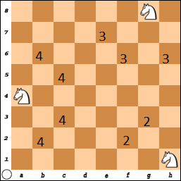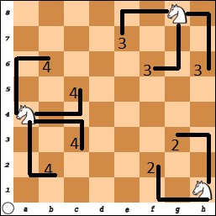

In this next diagram, the Knight is moved one square away from an edge and can now reach to six (6) squares.
This might look like a complex picture, but just think if it was a real game!

The four Knights cover 24 squares on the board.
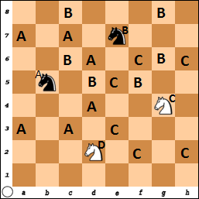

Notice the 'B' and 'D' Knights
start on a dark dark square
and will land on a light square.

The 'A' and 'C' Knights start on a light square and will land on a dark square.

Can you identify where the
“D” Knight can go?

They all will be ‘White’ Squares
Squares: b1, b3, c4, e4, f3, f1
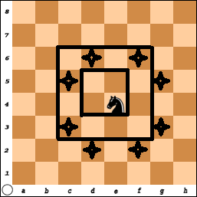
As the Knight moves towards the center (or actually 2 squares from an edge),
it can cover a maximum of eight (8) squares.

The Knight on e4 reaches to:
d6, f6, g5, g3, f2, d2, c3, and c5.

What squares would a Knight cover if placed on d4, d5 and e5?

Answers:
From d4: b3, b5, c6, e6, f5, f3, e2, and c2
From d5: c3, b4, b6, c7, e7, f6, f4, and e3
From e5: c4, c6, d7, f7, g6, g4, f3, and d3

Another way to think about how the Knight moves is to see how it moves in relationship to the Rook and the Bishop.

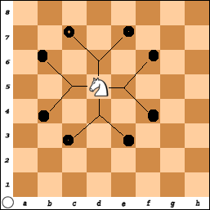
The Knight is between the
Rook and the Bishop.

The Knight can move 1 square:
Left or Right or Up and Down
(Like the Rook).

And then 1 square on the diagonal:
(Like the Bishop).

The Pawn Game
With Knights

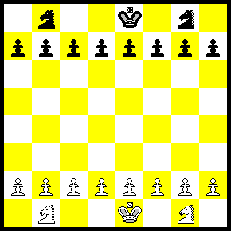

You have learned how to use various pieces:

You can now practice using 1 or 2 Knights.
You could also play with or without the Kings.
- Play without the Kings and try to get a Pawn across the board.
or
2) Play with the Kings on the board and try to checkmate.
IT IS NOT POSSIBLE TO CHECKMATE WITH ONLY TWO KNIGHTS
(Insufficient Mating Material)

Remember, even though you start the game with all your pieces, most of these are often captured during the game.

Finally, at the end, you will have a few pieces left that are used to get the checkmate.

Learn to use the pieces you have.

Review how the other pieces move and solve the puzzles.

Knight #1 - White wins with one move!  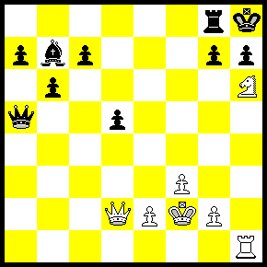 | Knight #2 - White Wins the Queen! 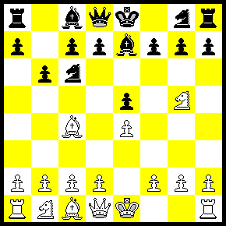
Knight #3 - White wins the Queen (again)  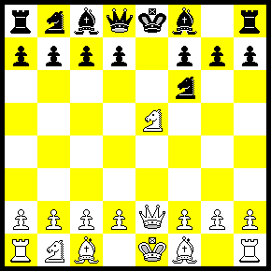 | Knight #4 - White moved Q-h7+. Next?  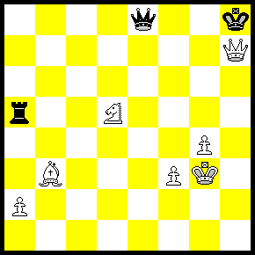
Knight #5 - What should White do?  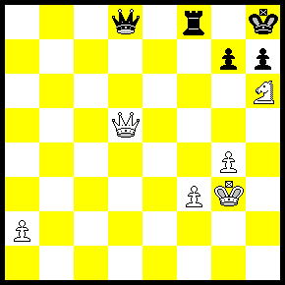 | Knight #6 - Is it even? White to move.  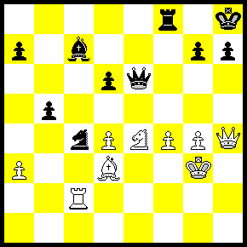

Answers:

#1) Knight f7 # Checkmate (This is called a SMOTHERED MATE),

#2) After just a few moves, Black is going to lose his Queen:
(This is not great chess but it did happen!)
1) e4 e5 2) N-f6 N-c6 3) B-c5 P- b6 4) N-g5 Be7 ????
Why didn’t Black just play Q x N !
White is lucky and plays…..5) N x f7 –
and where does the Queen go?

#3) Only four moves into this game and Black is going to lose his Queen.
1) e4 e5 2) N-f3 N-f6 3) NxP NxP?! 4) Q-e2 Nf6??
N-c6 Discovered Check and attacks the Queen.

#4) White just played Queen - h7 Check.
What was he thinking? Mistake or very clever?
Black MUST play King x Queen.
Now... Knight - f6 Check and Forks the King and Queen.
White should win with the Knight and Bishop (and Pawns)
against the Rook.

#5) White can play Queen x Queen.
Black would need to play Rook x Queen.
But then White plays: N - f7 Check and FORKS the Rook and King,
and should be able to win. (This looks very close to Problem #1.)
Queen - g8!!! Check.
(The King cannot capture the Queen because it is protected by the Knight)
So, Rook x Queen
Then, Knight - f7 Mate.

#6) It looks about even but...Queen x h7 Check.
The King must capture the Queen.
Now... Knight - f5 Double Check (with Knight and Bishop)
and forks the Queen with the Knight.
If King – h6???? then White plays R-h2 Mate.
So, then King must move and then White has lots of things to capture.

