How the Bishop Moves:

Each player has two Bishops.
White starts on c1 and f1 Black starts on c8 and f8.

Notice one Bishop is on a ‘Light’ colored square, (f1 and c8)
and the other Bishop is on a ‘Dark’ colored square (c1 and f8).

Bishops remain and move on the same color square for the entire game.

If you ever notice both Bishops on the same color square,
it probably means a mistake was made somewhere during the game.
(But it is possible if a Pawn reaches the 8th rank and is promoted.)

The Bishops may move only on the diagonal and they can move only in one direction at a time. (They cannot bend a corner on a turn on the same move.)

A student once made the comment that the 'cut' on the top of the Bishop reminded her the Bishop moves on a diagonal.

A Bishop can cover anywhere from 7 to 13 squares depending on where it is on the board.

A Bishop in the corner can cover 7 squares A Bishop 1 square in covers 9 squares
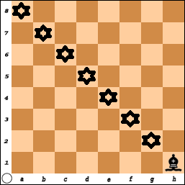 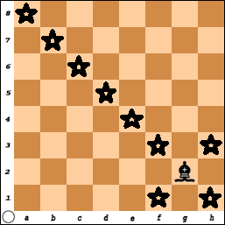
A Bishop that is 2 squares in covers 11. While a Bishop in the center covers 13.
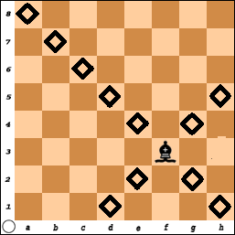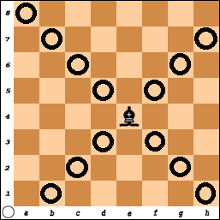

In the last four diagrams, the Bishop was on a 'light' square.

Place a Bishop on the 'dark' square (starting with a1, b2, c3, and d4) and count the number of squares that are covered. It is the same!

Did you notice how a Bishop in the corner has the least impact on the other squares, while a Bishop in the center has control over the most squares?

Review how the other pieces move and work together to solve the puzzles win material or the game.

The Pawn Game
With Bishops

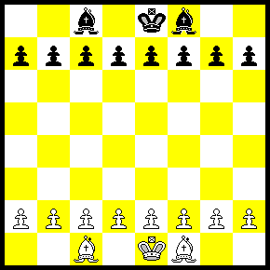

You can now play variations of the game where you each have one or two Bishops:

You could also play the game with or without the Kings.
- Play without the Kings and try to get a Pawn across the board.
(It is really hard to get a checkmate with two bishops).

Remember, even though you start the game with all your pieces,
most of these are often captured during the game.

Finally at the end you will have a few pieces left that are used to get the checkmate.

Learn to use the pieces you have.
Bishop #1 - What is Blacks Best move?  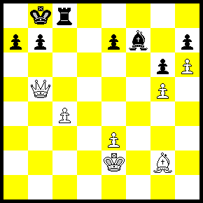 |  |  | Bishop #2 - Black to move.  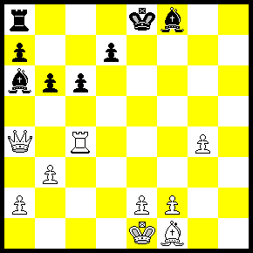
Bishop #3 - White to move and win.  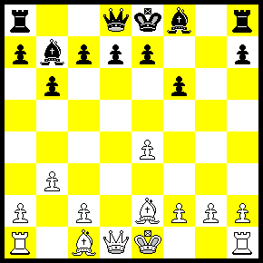 |  |  | Bishop #4 - Black Should win!  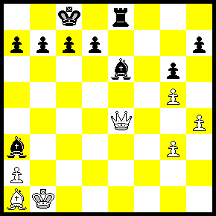
Bishop #5 - What should Black do now?  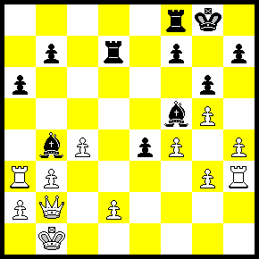 |  |  | Bishop #6 White should win!  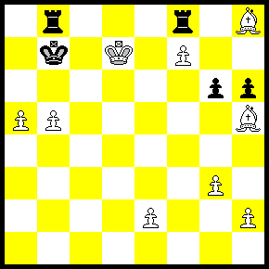

Answers:
#1) Bishop x Pawn (c4 Check). This “forks” the King and the Queen. White will not be able to capture the pawns at h7 or g6 and black should be able to win this game.

#2) Bishop to b5 - There is no place for the Queen to run.
a) Pawn to b5 “looks” like a strong move in that a little pawn is attacking the Queen and the Rook. White could just take the bishop and then after Black captures the Rook, the Queen will recapture the Pawn.
Since Black is behind, he cannot afford to give away any pieces.

b) A good defense is a strong offense. While the Queen and Rook are being attacked, White can counter-attack with Rook- e4 Check. The King must get out of check and then White can capture the Bishop for free!

#3) Bishop to h5 Checkmate. This is a little like the classic “Fools Mate”. It is a two-move checkmate – It is not forced but “White” sets himself up!
The weakest square is e2 for White and e7 for Black.
1) f3 (or f4) e6 (or e5)
2) g4 Q-h4 Mate

#4) Bishop to f5 is good since the Queen is ‘pinned’.
If the Queen takes the Bishop, the Pawn recaptures the Queen and it would be an easy game for Black.

If Black moves the Queen to d3, then B x Q Mate.
If Black moves Q-c2, then R-e1 Mate!

Another move would be: Bishop takes Pawn (a2), Check.
The King must capture the Bishop or move to c2.
Black then plays Rook x Queen.

#5) Pawn to e3 (Discovered Check) and White does not have a lot of options to play and Black should be able to promote the Pawn or win material.

#6) Bishop - f3 Check, King - a2. Bishop - d4 Check, Rook - b6
Bishop x Rook, King - b8
and White should be able to win.

