1) Pawns only move forward.
The Pawn is the only “man” or “piece” who cannot move backward.

2a) Any Pawn may move 1 or 2 squares the very first time it moves.
b) After a Pawn is moved once, it may only move 1 square at a time.

3) Pawns may not move forward if there is something on the square in front of it.

4) Pawns 'Move' forward but 'Capture' diagonally.

5) There are some other special rules for Pawns but you'll have to wait.

The Choices of the Pawn:
At most, the Pawn only has four choices to make:
1) Move ahead (1 or 2 squares if it is the 1st time to move)
2) Capture forward right
3) Capture forward left
4) Do not move
Before you play the Game-Of-Pawns, you should practice setting up the positions in the diagrams and answer the questions.

The Game of Pawns is not a “Real Chess Game” but it is a way for you to learn and practice some basic rules and moves of the game of chess.

Cover the answers before you try to solve these problems.
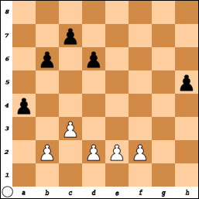 | #1)  Black Pawns on: a4, b6, c7, d6, and h5.  White Pawns on: b2, c3, d2, e2, and f2.  White moves first but Black is going to win this game!  The “Winner” is the person who gets a pawn across the board first!  Answer:  #1: All Black needs to do is keep moving his ‘h’ Pawn.  White can do nothing to stop the advance and black “wins” in 4 moves.
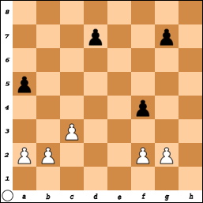 | #2)  Black Pawns on: a5, d7, f4, and g7.  White Pawns on: a2, b2, c3, f2, and g2.  What is the move that WINS for White?  Answer:  #2: Pawn-b4. If the black Pawn on a5 does not capture it, then White continues to move it down the board. If a5 takes the b4 Pawn, then c3 takes Black back and White still gets across the board first.
You could try to setup other puzzles before playing “The Game-Of-Pawns”.
The Game-Of-Pawns
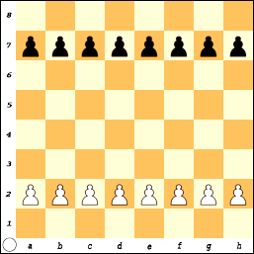
Rules:

The Game-Of-Pawns is an easy way to start you thinking about rules and moves.

- When you play this game, the way you win is to be the first player to get a Pawn to the other side of the board. THIS IS NOT A REAL GAME!

- If you cannot move, the game is over and the player with the most Pawns is the winner. (This is not true in a real chess game!)

- If both players have the same number of Pawns, the game is a tie or a DRAW. (Also not true for chess!)

- Remember, any Pawn may move one or two squares on their first move and then only one square at a time after that.

- Pawns move forward but capture diagonally.

- White moves first. Players alternate making a move.

- You may not skip or pass a turn.

- Play the game many times for practice.

- After each game, switch sides and play with the other color.

