At the beginning of the game, each player has 16 pieces, or men.
(Some chess books do not consider Pawns to be pieces)

There are only six unique pieces, and these pieces are called 'major' or 'minor' based on their strength and ability.

Surrounding the King are four different pieces or “men” (even though the Queen would be a lady!): The Queen, Bishops, Knights, and Rooks.

Beginners and “non-chess players” often think chess is a hard and complex game. However, there are just a few basic rules.

Each piece has a unique purpose and has their own individual strength.
However, to get started, you DO NOT need to know how all the pieces move at this time. Start with learning how to use each piece and then add more pieces.
Most Games have three (3) parts: Opening (Beginning), Middle and End Game.

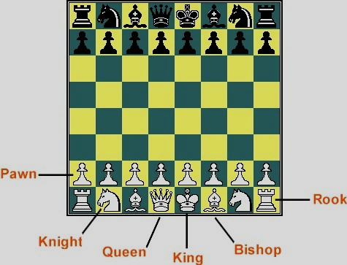
Now an important question:
WHO’S THE MOST IMPORTANT PIECE BOARD?
Answer:
ALL OF THE PIECES ARE IMPORTANT!
Queen | Every King needs a Queen.  A Queen starts the game on a square that “matches her dress”. (Queen goes on her own color).  The Queen is often given a value of 9 points.
Rook | Rooks are sometimes called Castles, (but use the word ROOK).  The Rooks go in the corners.  A Castle is a fortress, strong and sturdy.  They were made of Rock.  Kings lived in castles. ROOK is close to ROCK.  The Rook is often given a value of 5 points.
Knight | The Knights are next to the Rooks.  Knights rode horses, so the horse is the symbol for the Knight.  Horses can jump over things.  The Knights also protected their King.  The Knight is often given a value of 3 points.
Bishop | The Bishops are part of the Church.  The early Kings thought they were appointed by God.  The Bishops are near the King and Queen.  The Bishop is often given a value of 3 points.
Pawn | The Pawns are the most numerous but considered the weakest piece. However, at the end of the game, they may be the only pieces that remain.  If a Pawn crosses the board, it may be exchanged or promoted for another piece. (but not a King)!  Pawns are assigned a value of 1 point.
King | Without a King there could be no game.  The objective of the game is to capture your opponent's King.  This is called CHECKMATE. (The King cannot escape)  However, the King is never removed from the board.  The King is not assigned a value. He is Priceless!

Quick Value of Pieces:
When deciding what to move and what to capture, each piece can have a value assigned to it based on its strength. These point values have no meaning in regard to who is winning the game. The “point value” should only be used to help identify if a move may have merit. The situation on the board will determine the value of a piece. (Location – Location – Location)!

