Minutes are finite; so much is undone.
Abundant life given by the blessed Son.
Years have passed and years will come,
A future secure with faith in one.
Nourished by love, strengthened by trials,
Distances covered, not measured in miles.
The days are short, the journey is long -
How one path is right, and others are wrong.
Only a few will travel, though the road is free.
Many stumble through darkness and fail to see.
A time will come, yet the day's unknown -
Stand strong, rejoice, let truth be shown.
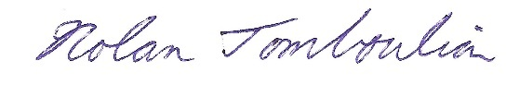
Nolan Tomboulian
August 1996

