Here are four problems for you to solve.
The challenge of chess is to be able to see and solve problems.
The answers to these problems are at the end of the chapter.
You may want to set the pieces up on a real board.
Try to avoid moving the pieces until you see the answer.
You cannot touch the pieces to try different things in a tournament so try not to touch them now.

Practice seeing the answer in your mind.
Puzzle #1
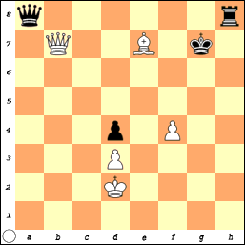
What a difference a move makes!
If it was Black’s turn, what is he attacking?
He is attacking the Queen on b7, but he could also have a checkmate in 3 moves.

But, it is White’s turn and he can turn this game around.

Hint: it is “double trouble” for Black.

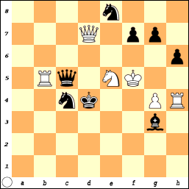
Puzzle #2
Black is in Check by the White Queen.

What is the correct way to get out of this danger? B.M.o.C.

Puzzle #3
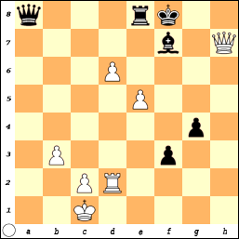
White is about to be checkmated if Black moves: Q-a1#.

But White has her own plans.

Hint: A good defense is a strong offense
(and White wins in 3 moves).

Puzzle #4
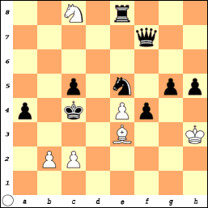
White seems to be in serious trouble, but all is not lost for much is to be gained (and it is not the Queen)!

White to move and win in 2 moves!

Puzzle #1
If it is Black's turn, he is attacking Q X Q which would be very good.
But, a better move for Black is the move that wins the game!
Q-a2+ or R-h2+ are fine moves.
Q-a2 +, Q-b2 blocks the check.
Then Q x Q+, K-c1 or K-d1 or K-e1
Then R-h1 # checkmate.
If R-h2 +, Q-g7 Blocks the check
Then R x Q +, K-c1 or K-d1 or K-e1
Then Q-a1 # checkmate.

If it is White's turn, he is attacking the Queen, but if Q x Q,
Black plays R x Q and black should win.

White has an attack with B-f8 +. The King is in double-check by the Bishop and the Queen.
If K x B, then Q x Q+, K-g7, Q x R and White should win.

If the King moves to get out of check (g8, f6, g6), then Q x Q.

Puzzle #2
Black is in check and his Queen is also under attack by the Rook.
Black cannot capture the Queen so he must Move or Block.
Move:
The King only has one square to move to c3.
All of the other squares are covered.
But then White plays Q-d3 # checkmate.
or Block:
Q-d5, Q-d6, Nc4-d6, or Ne8-d6
Both Queen moves might work but the analysis is very deep.
A good defense is a strong offense.
Nc4-d6 + - Blocks the check from the Queen and puts White in check and White has no way to get out of check except Q x N.
Black now has lots of options but N x Q #
is the best since it again forks the Rook and the King with another check!
Puzzle #3
Puzzle #3
White is about to be checkmated when Black moves Q-a1 #.
White could move his King to take action to avoid being checkmated.
K-b1, K-b2 and K-d1 are the three squares where the King could move. Which of the three is the worst move?
K-d1? since, Q-a1 # is still checkmate, because the Pawn on f6 covers the escape square.

So, White tries an attack of his own.
Q-h8 +, the King must block with B-g8.
Q-h6 +, and the King must move to f7.
Q-f6 #

Puzzle #4
White is down a lot of material, but the game is not decided by the number of pieces on the board! It is not over until it is over!
N-d6 + forks the King, Rook and the Queen so the
King has to move. There is only 1 square: K-b4.
Now, White could take the Queen.
But the strongest move is the one that wins the game.
B-d2 #.

Sometimes the answers are obvious and sometimes they are not.
However, nothing on the board is ever hidden. Every action has a consequence.
If you concentrate too hard on one thing, you can miss something else.
You need to see the whole board and how every piece interacts with every other piece. The choices we make are very important.

Pray for the strength, wisdom, and assurance to get through problems that pop up in your life. Even though you may not see a way out today, no problem is ever too great for God. You might not like the way a problem is resolved (for now) but God's way is always the right way. You might not understand why things turned out the way they did, and you might never understand from the human perspective, for you do not see the picture God sees.

