The giving of something of great value

The sacrifice can be a very important strategy in chess. It was so important to God! In the Old Testament, people used animals, alters and fires for sacrifices to God. The ultimate “sacrifice” was when Jesus (also known as The Lamb of God) went to the cross to pay the penalty for all sins. It is by His blood we are able to come into the holy presence of God’s Grace.
The next day John saw Jesus coming toward him and said, “Look, the Lamb of God, who takes away the sin of the world! (John 1:29)

... We have been justified by His blood, through faith.
(Eph. 1:7; Col. 1:14; Rev. 5:9)

What is a Sacrifice?
Imagine a wire was run across the rim of the Grand Canyon, Niagara Falls, the old Twin Towers of NY, or any other distance. How much money would you have to be offered before you would get on that wire and try to cross? Would you do it for $10,000? How about a million dollars? What about 100 million dollars? One more thing - you may not have a net, a safety wire, or any other protective device. If you fall you will die.

Most people I know will not take this challenge. Life is too short and too precious.
Life is something we want to hold on to and no price can be placed on it.

Now, let's place something on one side of the wire of great value. For example, what if there was someone on the other side who you loved very much.
Let's further imagine they are in danger and the only way they can be saved is if you cross the wire. The stakes have changed, and for many there is no amount of money that could be offered to keep them off the wire.

God so loved the world that he gave his only son (John 3:16)

God is love. (John 5:19)

God wants us to have a relationship with Him, and He allows us to know Him and love him through His son Jesus Christ and the Holy Spirit. Accepting Jesus and the sacrifice He made for us is the only way we can win and know we have eternal life and a secure place in heaven.
You must give up something of value for it to be called a sacrifice. A poor man who gives freely (though he has little) is better than a rich man who gives plenty but who's heart is not on God. God does not ask that we give equally, only that we give proportionally and lovingly. Everything we have is a gift of God; where we live, the job we have, the people we know, the health we have and the things we do. (Mark 12:41-44, Luke 21:1-4)

In chess nothing really compares to the sacrifice God made for us with the death of Jesus, but here are some examples that can show how giving up something of value now can produce rewards in the future.
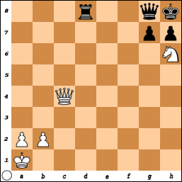
In this picture, White is about to be checkmated if Black plays R-d1+. There is no way for the King to move and he cannot capture the Rook. The only way out of check is to block with the Queen (Q-c1). Black plays R x Q ++

Black could also play Q x Q or P x N; but that doesn’t win the game!

However, it is White’s turn to move! NxQ? is NOT a good move. It does win the Queen, but White has gotten greedy and will lose the game when Black still plays R-d1+.

White also could play Q x Q+. Black must capture the queen with the Rook.(K x Q is not allowed since the King would be in check by the Knight). White Plays N x R and then KxN and White should be able to Queen a pawn first and win the game.

But, are there any other options after Q x Q+, R x Q. White plays: N-f7++ (Smothered Mate)

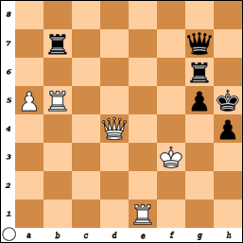
Here is another position with the major pieces still on the board. One strategy is to “exchange down” to get to a simpler end-game.

Q x Q, Rg6 x Q; R x R, R x R.
If after Q x Q, Black doesn’t want to exchange down, he could play Rb7 x Q and you would have a different end-game.

However, White has a very powerful move. Q x P+
Black cannot respond with P x Q since it is “pinned” it cannot move without exposing the King to a Check from the Rook on b5. So, K x Q is the only legal move.

Now White plays R-h1 ++.
White gave up the Queen in order to achieve the victory!

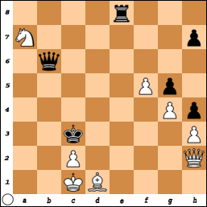
Here is another situation where Black is about to win the game. Q-b2++. But it is White’s turn. The Knight on a7 is also under attack and has no square to escape and cannot be protected by any other piece.
Moving the Bishop to e2 or f3 doesn’t help much either.
After Q-b2, K-d1; Q-B1++

To get out of this, White sees an interesting move. Q-c7+.

The King is in check and is also attacking the Queen. (Double Attack / Fork)
If Black moves the King, White just takes the Queen.
So, Black plays Q x Q. Now, White plays N-b5+ (and it also “Forks” the Queen).

Thank God for the sacrifice of Jesus who gave His life on the cross to pay the debt and take the penalty for my sin so I may claim his gift by faith and have the gift of eternal life.

It is not just to have an eternal life with God in Heaven, but it is also to have an abundant life now, here on earth. (John 10:10)

