The “Gift” to the Pawns

You have learned the Pawns are considered the weakest pieces on the board, but the Pawn is also blessed with a special gift. A Pawn that remains faithful and true and serves his master and reaches the other side of the board will be rewarded. The reward for the Pawn is the gift of a new life. When the Pawn reaches the last rank on the board, it transforms into a new being.

For White, this means marching the Pawn from the 2nd rank to the 8th rank. Black moves his Pawns from the 7th rank to the 1st rank.

A Pawn can become another Queen, Rook, Knight, or Bishop. It no longer is a Pawn. Its past life is gone and it takes on all of the strengths and abilities of the new piece.
You must be born again
John 3:3

You are blessed you do not have to go all the way through life or prove yourself before you claim Jesus. You can be transformed into a new 'piece' any time you place your faith in Jesus.

If a Pawn can get across the board, it must be promoted or exchanged for any other piece (except a King - there can only be one King). This is a very rare thing to happen and when it does, the Pawn is usually replaced with any piece that has previously been captured.

However, the rule is the Pawn may be promoted to ANY PIECE.
Therefore, it could be possible to have 9 Queens - the original plus 8 promoted Pawns.
It could also be possible to have 10 Knights, 10 Rooks or 10 Bishops.

You have learned a Rook is all that is needed to win (When working with the King).
You must remember the purpose of the game is to checkmate the other King.

Moves spent getting more pieces are just a waste of time.
Only get what you need and use what you have!
When a player keeps promoting his Pawns to other pieces, this shows he might not really know how to checkmate. Do not give up! The game is not over until you are checkmated. You might not be able to win but you will not lose as long as you are still playing. There is a very big danger with having too many Queens.
Queens are very powerful, but a Queen in the wrong place is worthless.
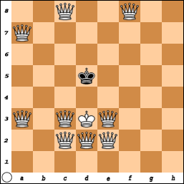
In chess (as in life), too much of a good thing is not always a good thing. Unlike Jesus who is a good thing you can never get too much of.

In a friendly game, a Rook turned upside down works pretty well (temporarily) for a Queen.

When you are playing in a tournament, you have the right to have a real piece placed on the board.

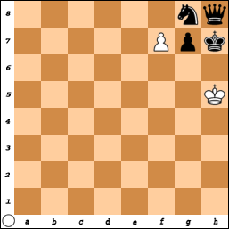
Remember, you can exchange the Pawn to become any piece. It does not have to be one who has previously been captured.

Normally, a Pawn is promoted to the most powerful piece, but this example shows another answer.

White has three choices:
1) P x N = Q. But black would just play
Q x Q and White would be in trouble.

2) P-f8=Q? But Black would just play N-f6 Check.

White would move the King and then Black would play QxQ. White could capture the Knight with QxN but then Black would play PxQ and have an easy win.

3) P-f8 = N !!! Checkmate.
It is not always this easy, but when you are given a “gift” you need to take it!

Just imagine how good it must feel to receive the gift of eternal life from GOD!

