A general principle in chess is to never believe what your opponent says as fact. They may know less about something than you do! Only believe what you know to be true or know where to go to find the truth.

In chess, the answers and rules are found in the USCF Official Rules of Chess. The Bible is the book of rules and examples for Christians. But, the Bible is not just a Rule Book – It is also a love letter and history book! Some people will try to claim that if something “is not” in the Bible, then it is OK to do it! – No – you have to apply God’s standard – Is it Holy, Is it just, is it fair?

Remember that knowing the rules does not make you a great chess player, it only allows you to play the game.
Know the rules, try to master them, and always try to live by them.

If you do not know something or are uncertain, read about it, think about it, pray about it, and then do something about it.

CASTLING
Since the King is the central piece in the game, it is important that he is protected. The King can often be protected best by being in the corner but since he may only move one square at a time it is hard for him to move there.

“Castling” is the one time when a player is allowed to move two men on the same turn: the King and the Rook.

One general idea keep in mind is to castle as quickly in the game as you can. There is a danger. If you wait too long, you may get into a position where you will be unable to take advantage of this special move. You can castle at any time during the game as long as a few rules are followed.

You can also accept Jesus into your heart and life at any time. It is never too late to ask Him to become your Savior and your Lord. Well, there are two times when it will be too late: when Jesus returns and you have not placed your faith in His name or if you die without calling on Him.
When Jesus returns, and He promised he would, there will be two groups of people, the SAVED and the LOST. (Matthew 3:12, 25:31-46).
If you would like to receive Jesus into your heart, you do not have to go to a church or wait until Sunday. You can do it right now!
However, once you accept Jesus, it is very important for you join a local New Testament Church.

A New Testament Church is one that:
    - Worships The Living God, Jesus Christ.
    - Believes the Bible is the Word of God.
    - Believes in the Trinity of God the Father, Jesus the Son, and the Holy Spirt. (Jesus was God, Made Flesh: John 1:10)
    - Jesus died to pay the penalty for sin, was buried but arose on the 3rd day.
    - It is by an act of Faith that God’s gift of eternal Life is received and not from “acts” of behavior or moral code of conduct.

Satan will tempt you, confuse you, and attack you. You must be strong and seek help from your brothers and sisters in Christ for all who call on His name become the Children of God. (John 1:12).

Pray God will lead you to a church where Jesus is worshiped. We have all been given gifts to glorify the kingdom, and He calls us to be a member of the body.

Special Rules for Castling
1) The King and the Rook must be on their original squares.
2) Neither piece may have been moved during the game.
Keeping notation is a way to 'remember' if the King or Rook has been moved.
3) The King cannot castle to get out of check.
You must seek protection BEFORE you are in danger.
4) The King cannot castle if he will pass through a square that is being attacked. Since a King cannot place himself in check, he may not castle through a square that would place him in check. (If the king moved 1 square at a time, would he be in check?)
5) There can be no other pieces between the King and the Rook.
How to Castle

The King moves over two squares (toward the Rook), and the Rook jumps over the King and lands beside him.

On the KING side
or castling 'short', the King moves two squares to the right and lands on the Knight square (g file)
and the Rook lands on the Bishop (f file) square.

O - O is chess notation for King side Castling.

On the QUEEN side
or castling 'long' , the King moves two squares to the left and lands on the Bishop square (c file)
and the Rook lands on the Queen square (d file).

O - O - O is the notation for Queen side Castling.

You should always move the King first. Since a King can normally only move one square, moving two squares means you are castling.

Remember the 'TOUCH MOVE' rule? It says if you touch a piece, your opponent may make you move it? Thus, if you touch the Rook first, your opponent might try to claim you cannot castle since you have moved your Rook.

Be careful! The American rule does allow for either the Rook or the King to be moved first, but the International rule requires the King to be moved first.
Be safe and move the King first.
Some players even use two hands to move both pieces at once but this is not really necessary.
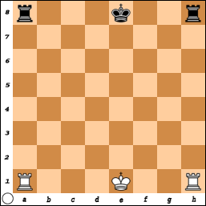
Here is a board without any of the other pieces. (It would be unlikely this position would ever occur). The Kings and Rooks are in their original position (and never have moved).

Even if the Rook and King are in their original position, if either had ever been moved, you may not Castle.

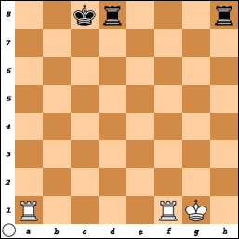  White has Castled Short or on the King side  and  Black has Castled Long on the Queen Side | 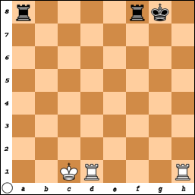  Black has Castled Short on the King Side  and  White has Castled Long on the Queen Side.

The king always moves two squares and the Rook jumps over it and lands by his side.
Neither White nor Black have moved their King or Rook, so both sides could castle if the other rules are met.

When thinking about moves, remember the three questions to ask:
1) What is under attack right now?
2) What is about to be attacked?
3) What can I attack? (or do to avoid being attacked).

What is the Best Move for White?
a) O-O-O ????
Why would this be a Very Very Very bad move?
Black would play Q-b1 ++ Checkmate.

b) How about N x Q? or P x Q? - either move wins the Queen!
But what would Black do next?
Black would play R-h1 ++ Checkmate.

c) Is N x N +a good move?
This does put the Black King in Check - Is the Game Over?
No... B x N,
and White is lucky R-c8 is still Checkmate.
But why waste time....

d) White plays R- c8 ++ Checkmate and the game is over.
What if it is Black's turn?

a) Save the Queen!
Good thought but is there a winning move?
Question #3) What can I attack? - Is it strong enough?

b) Castle
It cannot be done. The Bishop is covering a square the King would pass through. Too bad, the King waited too long to castle and now it is too late.

c) R- h1++ checkmate wins the game.

ALWAYS LOOK FOR THE WINNING MOVE.

REMEMBER THE OBJECTIVE.

THE GAME IS NOT OVER UNTIL THE LAST MOVE IS MADE.

Don't wait until it is too late and something keeps you from a relationship with Jesus Christ.

Pray so you may come to know Jesus and share His love with others.

