The KNIGHT is unlike any other piece on the chess board.
All the other pieces can only move and make captures on squares they touch.
The Knight can 'RISE UP' over other pieces.
His movement cannot be blocked by other pieces. The Knight starts between the Rook (Christ) and the Bishop (Church). The Knight links the church to Christ via the Holy Spirit. When Jesus was on the earth, his disciples were to follow him. However, when he arose, he said another would come in his place. (John 14:18)

Remember that this book only uses parables to help explain some principles in chess and is not an attempt to prove chess is based on anything in Christianity. This book was started because I used to spend a lot of time, energy and money trying to be a better chess player. After I accepted Christ into my life, I had to put Christ first above everything else.

God is with us today in the form of the Holy Spirit.

For the one whom God has sent speaks the words of God, for God gives the Spirit without limit. The Father loves the Son and has placed everything in his hands. Whoever believes in the Son has eternal life, but whoever rejects the Son will not see life, for God's wrath remains on him. (John 3:34-36)

By this he meant the Spirit, whom those who believed in him were later to receive. Up to that time the Spirit had not been given, since Jesus had not yet been glorified. (John 7:39)

The Knight always lands on a square that is the opposite color square from the color square where it came from.
It changes from white to black and black to white on each turn.

The Holy Spirit makes us change as well. God works in many ways that we often have trouble understanding. What may seem impossible to us is possible for God. He can change anything!
For nothing is impossible for God
Luke 1:37
In the song, Amazing Grace, the words tell how the wonderful power of the Spirit can find lost souls and bring them to God. It doesn't matter how ‘bad’ you might have been, God has the ability to lift away all sins. When you think there is no hope for you - it is because you do not see things as God sees them.

You must also realize that no matter how “Good” you think you have been, in God’s sight, you miss the mark.

For all have sinned and fall short of the glory of God.
Romans 3:32

All of us have become like one who is unclean, and all our righteous acts are like filthy rags; we all shrivel up like a leaf, and like the wind our sins sweep us away.
Isaiah 64:6

In chess, there are three ways to get out of danger: Block, Move, or Capture.

When you come in contact with the power of the Knight, it cannot be blocked out. You must either move away from it or capture it.

When the Spirit of God talks to you, you can not block it out - you must either run away from it or embrace it.

Don't run away from the power of God.
He offers the most wonderful gift of eternal life,
but you must accept it by faith.

"Do not let your hearts be troubled. Trust in God; trust also in me. .... "I am the way and the truth and the life. No one comes to the Father except through me......Anyone who has seen me has seen the Father. How can you say, 'Show us the Father'? Don't you believe that I am in the Father, and that the Father is in me? .... And I will ask the Father, and he will give you another Counselor to be with you forever-- the Spirit of truth. The world cannot accept him, because it neither sees him nor knows him. But you know him, for he lives with you and will be in you. I will not leave you as orphans; I will come to you.
(John 14:1-20)
How the Knight Moves:

Like the other pieces, the Knight only captures the piece on the square it lands on.
IT DOES NOT CAPTURE JUST BY MOVING OVER IT.

The Knight makes an 'L' shape move (over 2 and up 1 or up 1 and over 2).
(2+1=3, and on the third day, Jesus said he would rise up again.
Destroy this temple and in three days I will rise up. (John 2:19)

It will land on a square of an opposite color from where it was moved from.
If it starts on a White Square, it will land on a Black Square.
If it starts on a Black Square, it will land on a White Square.

Depending on where the Knight is, it can cover from two to eight squares.
Like the other pieces, the closer a Knight gets to the corner, the smaller the number of squares it can reach.

A Knight in the center can reach the most squares (eight).

Don't hide the Holy Spirit in a corner or along the edge.
Get Him into the center of the action where He can do the most good.
One student said the 'Knight' reminds her of an upside down 'L' and the Knight moves in an 'L' shape. Do you see the 'L' shapes the Knight makes?

The numbers '2', '3', and '4' show the number of squares the Knight can reach from different starting positions.

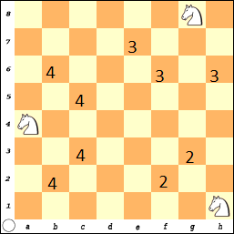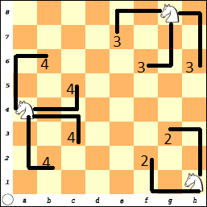

In this next diagram, the Knight is moved one square away from an edge and can now reach to six other squares.
This might look like a complex picture, but just think if it was a real game!
The four Knights cover 24 squares on the board.
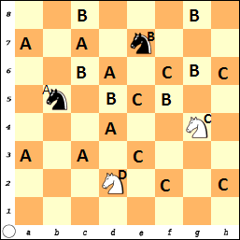
Notice the 'B' and 'D' Knights start on dark squares and will land on light squares.

The 'A' and 'C' Knights started on light squares and will land on dark squares.

The Knight on d2 is on a Black Square.
What six (6) White squares will it land on?

Answer: b1, b3, c4, e4, f3, f1.

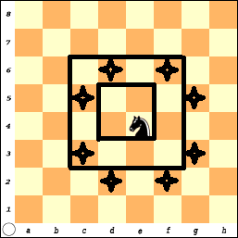
As the Knight moved towards the center (or actually 2 squares from an edge), it can cover a maximum of 8 squares.
The Knight on e4 reaches to:
d6, f6, g5, g3, f2, d2, c3, and c5.

What squares would a Knight cover
if placed on d4, d5 and e5?

Answers:
D4: b3, b5, c6, e6, f5, f3, e2, and c2
D5: c3, b4, b6, c7, e7, f6, f4, and e3
E5: d3, c4, c6, d7, f7, g6, g4, and f3

Another way to think about how the Knight moves is to see how it moves in relationship to the rook and the Bishop.

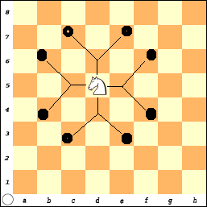
Since the Knight is between the Rook and the Bishop:

The Knight can move 1 square Left or Right or Up and Down (like the Rook).

And then one square on the diagonal (like the Bishop).

Let the Spirit of God work through you.

Henry Blackaby writes in his book, “Experiencing God: Knowing And Doing The Will Of God”, you need to look and see what God is doing and ask to join Him. God is always at work!

Pray the Holy Spirit will lift you up and guide you through the day, that obstacles will fall before you; and changes will take place in your life.
Examples of God the Spirit
Mary is told of the life that she is to carry.
The angel answered, The Holy Spirit will come upon you, and the power of the Most High will overshadow you. So the holy one to be born will be called the Son of God.
Luke 1:35

John tells that the King is coming.
John answered them all, "I baptize you with water. But one more powerful than I will come, the thongs of whose sandals I am not worthy to untie. He will baptize you with the Holy Spirit and with fire.” Luke 3:16

God tells the word who Jesus is.
and the Holy Spirit descended on him (Jesus) in bodily form like a dove. And a voice came from heaven: "You are my Son, whom I love; with you I am well pleased." Luke 3:22

Jesus tells the people why he can do what he does.
"The Spirit of the Lord is on me, because he has anointed me to preach good news to the poor. He has sent me to proclaim freedom for the prisoners and recovery of sight for the blind, to release the oppressed, to proclaim the year of the Lord's favor."
Luke 4:18-19

Jesus tells the people what the Father wants them to know.
At that time Jesus, full of joy through the Holy Spirit, said, "I praise you, Father, Lord of heaven and earth, because you have hidden these things from the wise and learned, and revealed them to little children. Yes, Father, for this was your good pleasure. "All things have been committed to me by my Father. No one knows who the Son is except the Father, and no one knows who the Father is except the Son and those to whom the Son chooses to reveal him." Then he turned to his disciples and said privately, "Blessed are the eyes that see what you see. For I tell you that many prophets and kings wanted to see what you see but did not see it, and to hear what you hear but did not hear it." Luke 10:21-24
John tells That God says the Spirit will communicate with us.
I would not have known him, except that the one who sent me to baptize with water told me, “The man on whom you see the Spirit come down and remain is he who will baptize with the Holy Spirit.” I have seen and I testify that this is the Son of God." The next day John was there again with two of his disciples. When he saw Jesus passing by, he said, "Look, the Lamb of God!"
John 1:33-36

What Jesus said about how you have eternal life.
Jesus answered, "I tell you the truth, no one can enter the kingdom of God unless he is born of water and the Spirit. Flesh gives birth to flesh, but the Spirit gives birth to spirit. You should not be surprised at my saying, 'You must be born again.' The wind blows wherever it pleases. You hear its sound, but you cannot tell where it comes from or where it is going. So it is with everyone born of the Spirit." John 3:5-8

What Jesus said about his death and what was to follow.
But the Counselor, the Holy Spirit, whom the Father will send in my name, will teach you all things and will remind you of everything I have said to you. Peace I leave with you; my peace I give you. I do not give to you as the world gives. Do not let your hearts be troubled and do not be afraid. "You heard me say, 'I am going away and I am coming back to you.” If you loved me, you would be glad that I am going to the Father, for the Father is greater than I. I have told you now before it happens, so that when it does happen you will believe. I will not speak with you much longer, for the prince of this world is coming. He has no hold on me, but the world must learn that I love the Father and that I do exactly what my Father has commanded me. "Come now; let us leave.” John 14:26-31

Jesus talks to the disciples about the one who will follow Him.
"Do not let your hearts be troubled. Trust in God; trust also in me. In my Father's house are many rooms; if it were not so, I would have told you. I am going there to prepare a place for you. And if I go and prepare a place for you, I will come back and take you to be with me that you also may be where I am. You know the way to the place where I am going." Thomas said to him, "Lord, we don't know where you are going, so how can we know the way?" Jesus answered, "I am the way and the truth and the life. No one comes to the Father except through me. If you really knew me, you would know my Father as well. From now on, you do know him and have seen him." Philip said, "Lord, show us the Father and that will be enough for us." Jesus answered: "Don't you know me, Philip, even after I have been among you such a long time? Anyone who has seen me has seen the Father. How can you say, 'Show us the Father'? Don't you believe that I am in the Father, and that the Father is in me? The words I say to you are not just my own. Rather, it is the Father, living in me, who is doing his work. Believe me when I say that I am in the Father and the Father is in me; or at least believe on the evidence of the miracles themselves. I tell you the truth, anyone who has faith in me will do what I have been doing. He will do even greater things than these, because I am going to the Father. And I will do whatever you ask in my name, so that the Son may bring glory to the Father. You may ask me for anything in my name, and I will do it. "If you love me, you will obey what I command. And I will ask the Father, and he will give you another Counselor to be with you forever-- the Spirit of truth. The world cannot accept him, because it neither sees him nor knows him. But you know him, for he lives with you and will be in you. I will not leave you as orphans; I will come to you. Before long, the world will not see me anymore, but you will see me. Because I live, you also will live. On that day you will realize that I am in my Father, and you are in me, and I am in you.
John 14:1-20
What believers must do after Jesus is gone.
When the Counselor comes, whom I will send to you from the Father, the Spirit of truth who goes out from the Father, he will testify about me. And you also must testify, for you have been with me from the beginning. John 15:26-27

Why Jesus has power.
All that belongs to the Father is mine. That is why I said the Spirit will take from what is mine and make it known to you. "In a little while you will see me no more, and then after a little while you will see me." John 16:15-16

The Great Commission
Then Jesus came to them and said, "All authority in heaven and on earth has been given to me. Therefore, go and make disciples of all nations, baptizing them in the name of the Father and of the Son and of the Holy Spirit, and teaching them to obey everything I have commanded you. And surely I am with you always, to the very end of the age." Matthew 28:18-20

The price Christ paid for our sins.
How much more, then, will the blood of Christ, who through the eternal Spirit offered himself unblemished to God, cleanse our consciences from acts that lead to death, so that we may serve the living God! For this reason, Christ is the mediator of a new covenant, that those who are called may receive the promised eternal inheritance-- now that he has died as a ransom to set them free from the sins committed under the first covenant.
Hebrews 9:14-15
The Promise of God.
Who have been chosen according to the foreknowledge of God the Father, through the sanctifying work of the Spirit, for obedience to Jesus Christ and sprinkling by his blood: Grace and peace be yours in abundance. Praise be to the God and Father of our Lord Jesus Christ! In his great mercy he has given us new birth into a living hope through the resurrection of Jesus Christ from the dead, and into an inheritance that can never perish, spoil or fade-- kept in heaven for you. 1 Peter 1:2-4
The Pawn Game
With Knights

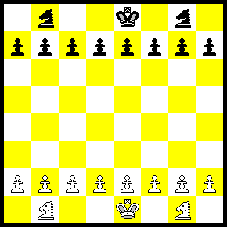

You have learned how to use all six pieces:
The Pawn, the Rook, the Queen, the Bishop, the Knight and the King.

You can now play variations of the game where you each have:
a) 1 Knight
b) 2 Knights
c) 1 Knight and 1 Bishop
d) 1 Knight, and 1 Bishop and 1 Rook
e) Etc. Etc.. Etc.

Each of the above options could also be played with or without the Kings.
- Play without the Kings and try to get a Pawn across the board.
or
2) Play with the Kings on the board and try to checkmate.

Remember, even though you start the game with all of your pieces, most of these are often captured during the game. Finally at the end you will have a few pieces left that are used to get the checkmate.
Learn to use the pieces you have.
Knight #1. White wins with one move!  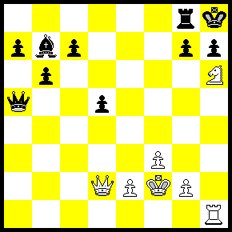 | Knight #2. White Wins the Queen! 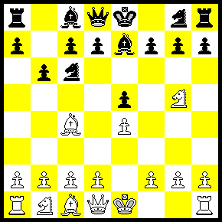
Knight #3.White wins the Queen (again)  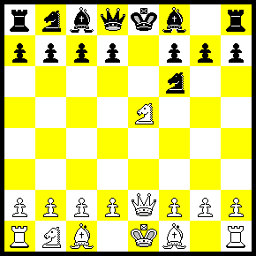 | Knight #4. White moved Q-h7+. Next?  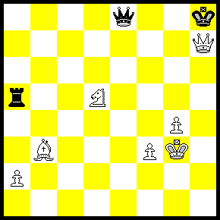
Knight #5.What should White do?  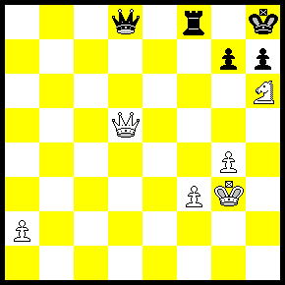 | Knight #6. Is it even? White to move  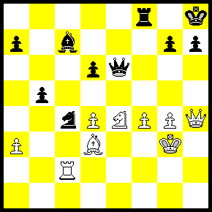

Answers

#1) Knight - f7 # Checkmate

#2) After just a few moves, Black is going to lose his Queen:
(This is not great chess but it did happen!)
1) e4 e5 2) N-f6 N-c6 3) B-c5 P-b6 4) N-g5 Be7 ????
Why didn’t Black just play Q x N !
White is lucky and plays….5) N x f7 - and where does the Queen go?

#3) After 4 moves into the game and Black is going to lose his Queen.
1) e4 e5 2) N-f3 N-f6 3) NxP N x P?! 4) Q-e2 Nf6??
N-c6 Discovered Check and attacks the Queen.

#4) White just played Queen - h7 Check. What was he thinking???
Black must play King x Queen.
Now... Knight - f6 Check and Forks the King and Queen.
White should win with the Knight and Bishop (and Pawns) against the Rook.

#5) White can play Queen x Queen. Black would need to play Rook takes Queen
Then N-f7 Check and FORKS the Rook. This also looks like Problem #1.
Queen - g8!!! Check.
(The King cannot capture the Queen because it is protected by the Knight)
So, Rook takes Queen
Then Knight - f7 # Mate.

#6) It looks about even but...Queen x h7 Check. The King must capture the Queen.
Now... Knight-f5 Double Check (with Knight and Bishop)
and forks the Queen with the Knight.
If King – h6???? then White plays R-h2 Mate.
So, then King must move and then White has lots of things to capture.

