The BISHOP is an overseer, elder, or pastor charged with the responsibility of spiritual leadership in a local church.

The Bishops are those who exercise power or who hold positions of authority.

The Overseer or the Bishop is like a shepherd watching over the flock. Depending on the Bible translation, Jesus is called an "Overseer" or a "Bishop".

For you were like sheep going astray, but now you have returned to the Shepherd and Overseer of your souls.
1 Peter 2:25 NIV

For ye were as sheep going astray; but are now returned unto the Shepherd and Bishop of your souls.
1 Peter 2:25 KJV

The elders of the church at Ephesus were instructed to
Keep watch over yourselves and all the flock of which the Holy Spirit has made you overseers. Be shepherds of the church of God, which he bought with his own blood.
Acts 20:28

The Bible also has instructions, standards, and qualifications for Bishops, Deacons, and Elders for their personal and home life, as well as the Bishop's relationships with non-believers.

The Bishop was to oversee the flock of God, to shepherd his people, to protect them from enemies, and to teach, exhort, and encourage. He was to accomplish this primarily by being an example to his people. He was to do this willingly and with an eager spirit, not by force or for financial gain.

To desire a position as bishop, the apostle Paul declared, was to desire a good work (1 Timothy 3:1).
How the Bishop moves:

Each player has two Bishops.

You will notice one of the Bishops is on a ‘Light’ colored square,
and the other is on a ‘Dark’ colored square.

They will move on the same color square for the entire game.

If you ever notice you have both Bishops on the same color square, it probably means a mistake was made somewhere during the game. (But, it is possible if a Pawn reaches the 8th rank and is promoted).

The Bishops may move only on the diagonal and they can move only in one direction at a time. They cannot bend a corner on a turn.

A student once made the comment that the 'cut' on the top of the Bishop reminded her that the Bishop moves on a diagonal.

A Bishop can cover anywhere from 7 to 13 squares depending on where it is on the board.

A Bishop in the corner can cover 7 squares A Bishop 1 square in covers 9 squares
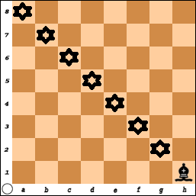 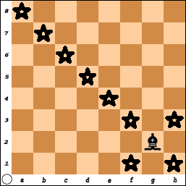
A Bishop that is 2 squares in covers 11 A Bishop in the center covers 13 squares
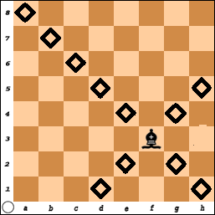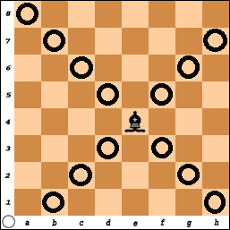

In the last four diagrams, the Bishop was on a 'light' square.

Place a Bishop on the 'dark' square (starting with a1, b2, c3, and d4) and count the number of squares that are covered. It is the same!

Did you notice how a Bishop in the corner has the least impact on the other squares, while a Bishop in the center has control over the most squares?

Where are you in your relationship with Christ and how you act in the world? Are you more in the corner or moving towards the center?

Are you like a Bishop in your church and in your home?
An elder must be blameless, the husband of but one wife, a man whose children believe and are not open to the charge of being wild and disobedient. Since an overseer is entrusted with God's work, he must be blameless - not overbearing, not quick-tempered, not given to drunkenness, not violent, not pursuing dishonest gain. Rather he must be hospitable, one who loves what is good, who is self-controlled, upright, holy and disciplined. He must hold firmly to the trustworthy message as it has been taught, so that he can encourage others by sound doctrine and refute those who oppose it. For there are many rebellious people, mere talkers and deceivers, especially those of the circumcision group. They must be silenced, because they are ruining whole households by teaching things they ought not to teach - and that for the sake of dishonest gain. Titus 1:6-11
Be shepherds of God's flock that is under your care, serving as overseers - not because you must, but because you are willing, as God wants you to be; not greedy for money, but eager to serve; not lording it over those entrusted to you, but being examples to the flock. And when the Chief Shepherd appears, you will receive the crown of glory that will never fade away. Young men, in the same way be submissive to those who are older. All of you, clothe yourselves with humility toward one another, because, "God opposes the proud but gives grace to the humble." Humble yourselves, therefore, under God's mighty hand, that he may lift you up in due time. Cast all your anxiety on him because he cares for you. Be self-controlled and alert. Your enemy the devil prowls around like a roaring lion looking for someone to devour. Resist him, standing firm in the faith, because you know that your brothers throughout the world are undergoing the same kind of sufferings. And the God of all grace, who called you to his eternal glory in Christ, after you have suffered a little while, will himself restore you and make you strong, firm and steadfast. To him be the power for ever and ever. Amen. 1 Peter 5:2-11

Here is a trustworthy saying:
If anyone sets his heart on being an overseer, he desires a noble task. Now the overseer must be above reproach, the husband of but one wife, temperate, self-controlled, respectable, hospitable, able to teach, not given to drunkenness, not violent but gentle, not quarrelsome, not a lover of money. He must manage his own family well and see that his children obey him with proper respect. (If anyone does not know how to manage his own family, how can he take care of God's church?) He must not be a recent convert, or he may become conceited and fall under the same judgment as the devil. He must also have a good reputation with outsiders, so that he will not fall into disgrace and into the devil's trap. Deacons, likewise, are to be men worthy of respect, sincere, not indulging in much wine, and not pursuing dishonest gain. They must keep hold of the deep truths of the faith with a clear conscience. They must first be tested; and then if there is nothing against them, let them serve as deacons. In the same way, their wives are to be women worthy of respect, not malicious talkers but temperate and trustworthy in everything. A deacon must be the husband of but one wife and must manage his children and his household well. 1Timothy 3:1-12
The Pawn Game
With Bishops

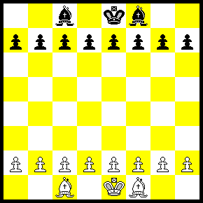

You have now learned how to use five of the six pieces:
The Pawn, the King, the Rook, the Queen, and the Bishop.

You can now play variations of the game where you each have:
a) 1 Bishop
b) 2 Bishops
c) 1 Bishop and 1 Rook
d) 2 Bishops and 2 Rooks
e) 1 Rook, 1 Bishop and 1 Queen
f) Etc. Etc.. Etc.

Each of the above options could also be played with or without the Kings.
- Play without the Kings and try to get a Pawn across the board.
or
2) Play with the Kings on the board and try to checkmate.

Remember, even though you start the game with all of your pieces, most of these are often captured during the game.
Finally at the end you will have a few pieces left that are used to get the checkmate.
Learn to use the pieces you have.
Bishop #1 - What is Blacks Best move?  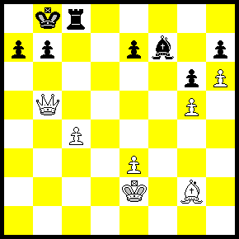 |  |  | Bishop #2 - Black to move.  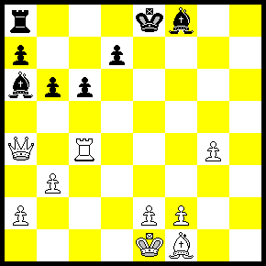
Bishop #3 - White to move and win.  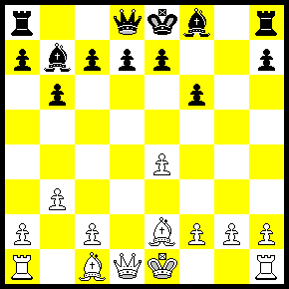 |  |  | Bishop #4 Black Should win!  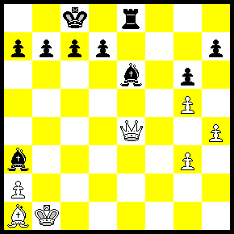
Bishop #5 - What should Black do now?  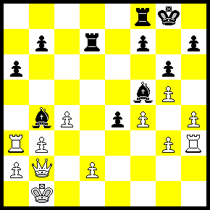 |  |  | Bishop #6 White should win!  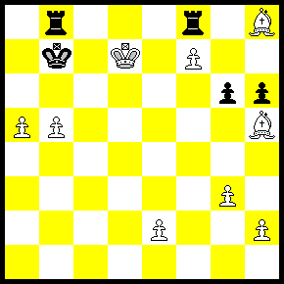

Answers:
#1) Bishop x Pawn (c4 Check). This “forks” the King and the Queen. White will not be able to capture the pawns at h7 or g6 and black should be able to win this game.

#2) Bishop to b5 - There is no place for the Queen to run.
a) Pawn to b5 “looks” like a strong move in that a little pawn is attacking the Queen and the Rook. White could just take the bishop and then after Black captures the Rook, the queen will recapture the Pawn.
Since Black is behind, he cannot afford to give away any pieces.

b) A good defense is a strong offense. While the Queen and Rook are being attacked, White can counter attack with Rook- e4 Check. The king must get out of check and then White can capture the Bishop for free!

#3) Bishop to h5 Checkmate. This is a little like the classic “Fools Mate”. It is a two move checkmate – It is not forced but “White” sets himself up!
The weakest square is e2 for white and e7 for Black.
1) f3 (or f4) e6 (or e5)
2) g4 Q-h4 #Mate

#4) Bishop to f5 is good since the Queen is ‘pinned’.
If the Queen takes the Bishop, the Pawn recaptures the Queen and it would be an easy game for Black.

If Back moves the Queen to d3, then B x Q # Mate.
If Black moves Q-C2, then R-e1 Mate!

Another move would be: Bishop takes Pawn (a2), Check.
The King must capture the bishop or move to c2.
Black then plays Rook x Queen.

#5) Pawn to e3 (Discovered Check) and White does not have a lot of options to play and black should be able to promote the Pawn or win material.

#6) Bishop f3 + Check, King - a2. Bishop - d4 Check, Rook b6
Bishop takes Rook, King -b8
and White should be able to win.

