So far, you have learned how to:
1) Set up the board: (Light on the Right).
2) How the Pawns move (Forward) and capture (Diagonally).
3) How the King moves: (1 square in any direction).
4) Terms of: check, checkmate and stalemate.

Remember, these lessons are not about showing God and Jesus in chess, but about learning how to play (and master) chess with some interesting parables and analogies to being a Christian.

At the beginning of the game, each player has two Rooks (one in each corner).

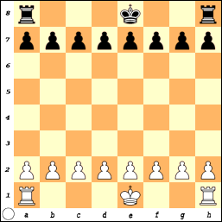
The Rooks are sometimes called CASTLES. (But, you really want to call them Rooks).

Castles are often made out of stone and were strong fortresses.

Jesus is sometimes called the Rock, fortress or High Tower.

The Rook is in the corner and Jesus is also called the cornerstone. The Cornerstone is the rock on which all others are placed.

He said: "The LORD is my rock, my fortress and my deliverer; my God is my rock, in whom I take refuge, my shield and the horn of my salvation. He is my stronghold, my refuge and my savior-- from violent men you save me. I call to the LORD, who is worthy of praise, and I am saved from my enemies. (2 Samuel 22:2-4)

The LORD is my rock, my fortress and my deliverer; my God is my rock, in whom I take refuge. He is my shield and the horn of my salvation, my stronghold. I call to the LORD, who is worthy of praise, and I am saved from my enemies. (Psalm 18:2-3)

In the New Testament, Jesus tells a parable
Haven't you read this scripture: "'The stone the builders rejected has become the capstone. (Mark 12:10)

Built on the foundation of the apostles and prophets, with Christ Jesus himself as the chief cornerstone. In him the whole building is joined together and rises to become a holy temple in the Lord. And in him you too are being built together to become a dwelling in which God lives by his Spirit. (Ephesians 2:20-22)
He only is my Rock and my Salvation; He is my Defense and my Fortress, I shall not be moved. (Psalm 62:6)
The Lord is good, a Strength and Stronghold in the day of trouble; He knows (recognizes, has knowledge of, and understands) those who take refuge and trust in Him. (Nahum 1:7)

Rooks have a very interesting trait.
No matter where a Rook is placed, it always covers 14 squares.

Other pieces get stronger as they move toward the center and weaker as they move toward the edges, but the Rook has constant and unchanging strength.
(Remember the king went from 3 squares in the corner to 5 squares on and edge and to 8 squares as it moved towards the center)

How the Rooks move:
UP or DOWN - Vertically in the columns or “Files”.

LEFT or RIGHT - Horizontally in the rows or “Ranks”.

The Rooks move in a straight line.

They cannot change direction during a move.

They can move forward or backward.

They cannot go through or jump over other pieces.
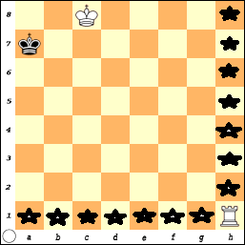
In this diagram, the Rook on h1 may move to: a1, b1, c1, d1, e1, f1, g1,
h2, h3, h4, h5, h6, h7 or h8.

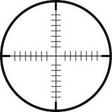
One student once said she remembers how the Rook moves because if you look at the top of it, the little cuts go left and right and up and down like the cross on a target.

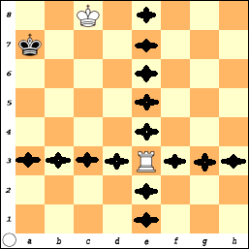
In this diagram the Rook on e3 also covers 14 squares. It may move horizontally in the 3rd Rank to: a3, b3, c3, d3, f3, g3, or h3.

It could move vertically in the e File to:
e1, e2, e4, e5, e6, e7, or e8.

PLACE THE ROOK ANYWHER ON THE BOARD
AND DISCOVER IT ALWAYS COVERS 14 SQUARES
Making the Box
Fence In the King
Just as there are many truths, facts, rules and interesting things in the Bible you should try to learn, follow and obey; there are rules in chess you will want to learn to become a better player.

One of the most basic principles in chess is how to win the game with just a few pieces.

Winning with a Rook requires the opponent’s King be against an edge of the board. It doesn't matter what edge - just pick one and make the 'Box'.

Since Rooks can move left, right, up and down, they can make a BOX or 'fence in the King' to an edge.

The Rook on e3 divides the board into four sections.

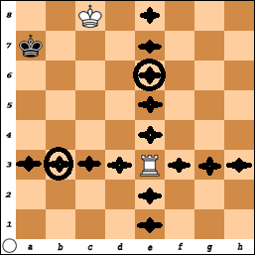
Since the Black King is on the ‘a’ File, he is already along an edge. White wants to keep the King in a limited area (Box).

So, white should either move the Rook to b3, c3, d3 or e6.

While moving to b3 actually does make a smaller box (5 squares) than e6 (12 squares), many players forget you also want to limit and restrict movement and choices of your opponent.

Since the White King also covers b7 and b8 (Kings can never be placed next to each other), moving the Rook to e6 forces Black to one square (a8).
Then White wins with Rook- a6 Mate

Moving the Rook to b3 allows Black the chance to escape and find room to move to a6.
Then you get into a situation where you chase the king around the edge of the board.

This was an example of one Rook and was easy since the King was against an edge.

How would you do it if the King was not on an edge?

Let’s learn how to use two Rooks together and then come back and try with one.
Power Punch

The power in one Rook is enough to win the game! When we talk about the power of God, Jesus, and the Holy Spirit it is an awesome power.
Some “religions” consider God, Jesus and the Spirit to be three different and unique entities – but the basic Christian belief known as the TRINITY says they are ALL THE SAME : 3-in-1. Yet, God can be manifested and present in all three forms at one time.

In the next example, there are two Rooks or double the power. You need to use the Rooks together as a team to keep pushing the King to an edge.

It is important for the Rook stays at least one square away from the opponent King. If a player is not careful, the King could capture the Rook. It is like falling into the trap of sin, if you walk too close to the line, you may get caught!

The lone Black King wants to stay away from the edge and move toward the closest Rook (hoping a mistake will be made to allow him to capture the Rook).
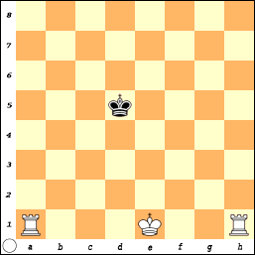
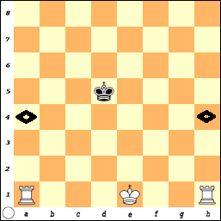
Starting from this position, White has to make a plan which edge she would like to force the Black King towards.

She decides she wants to push the Black King to the 8th Rank.

She has two possible moves that will limit and force the King to move.

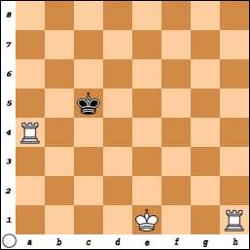
White decides to move: R-a4.

Since Black realizes he doesn’t want to move back towards the 8th rank, he wants to stay in the 5th rank. Thus there are two choices: c5 or e5.
Black also remembers the “rule” of Move towards the closest Rook. (Even though this is contrary to the idea of staying away from the edge)!
Sometimes you have to make choices!
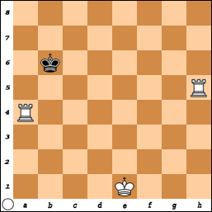
White continues to push the King back with the move Rook-h5 Check. The Black King is forced to move back to either: b6, c6, or d6. But, the rule says – Move towards the closest rook: King – b6.

So now the position looks like this.
This is where White can get in trouble if she just pushes her Rook to a6 Check +. The Black King can capture the piece that has put it in check! (B.M.o.C. Kings can capture pieces!)

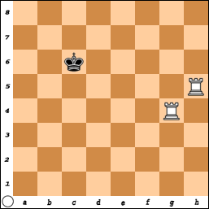
Moving the Rook on a4 to a5 is OK but still dangerous since moving the Rook on (h) could leave the Rook on unprotected. WHY TAKE A CHANCE?

The better move is Rook-g4! The Black King still cannot come forward. He doesn’t want to move back to 7th rank – so he stays in the 6th rank. That leaves a6 or c6.

But, the rule is move towards the closest Rook
So, King-c6.

But, Black has lost this game in three moves and White will force Black to the 8th Rank.
1) Rook-g6 Check + / King-d7.
2) Rook-h7 Check + / King e8.
3) Rook-h8 Checkmate ++.
It would not matter if the King moves to b7, c7 or d7 since he is too far away from the Rooks to hope White will make a mistake.
But since there is hope, the rule says move towards the closest Rook.
Make your opponent earn the Win – Don’t give up!

Place the Black King and two White Rooks on various squares on the board.
Practice this.......practice this.......practice this.
(You may remove the White King to do this exercise).

Even though this may seem like a silly exercise, it is very important.

I have seen many chess players 'think' they know how to solve this 'problem' only to fail when they are playing a game.

Let it not be said that you were not ready.
Be prepared for the ending when Jesus will return.

Know that you know you will win the game (of life).
Let there be no doubt in your mind.

Many people want to get close to Jesus but they don't know how to do it. On the chess board the King can just move just 1 step at a time. In life, you are blessed you can come to know Jesus in an instant by allowing him into your heart.

There does not need to be a lot of maneuvering, plotting and figuring it all out first. In fact, you cannot wait until you have it all figured out before you accept Jesus!

The greatest minds and philosophers have been debating the existence of God and Jesus for 2000+ years.

You can choose to believe it or not! But don’t try to wait for “Proof” to convince you! How much proof do you need?

Some people try to claim that the Bible is old, inaccurate or full of contradictions. However, there are more copies of scrolls of the New Testament and the date of their writings is close to the time it happened. If the Bible was not true, the “Stories” and claims made by the disciples would have vanished into history.
Most of the disciples were martyred for their faith.
Not many people would die for a lie!
You must call on his name by faith and then you can receive the gift of eternal life.
One Rook and a King

Like checkmate with two Rooks, to win with one Rook and a King:
1) The opponent must be against an edge.
2) Your King should be directly in front of his King.
3) Your final move must be to check with the Rook on the edge.
(A special case does exist if the King is near the corner.)

Be careful and make sure, if the King is not in check, he has a square to move to. You have learned the game is over when the King is in Checkmate.
In order to have checkmate, the King must be in check!
One saying often used is: “Check – It may be Mate!”

If the King is not in check, then it cannot be checkmate!

If the King cannot make a move, (and there are no other moves that can be made, and that will not put him in danger), then the game is over and it is called a 'Stalemate' or the game is draw or a tie.
Moving the Rook to C6 is not good since after the King moves to a7, the Rook cannot move to a6 for the final check.

The Rook should stay at least one square away from the opponent’s King.
The Game-Of-Pawns
With Rooks
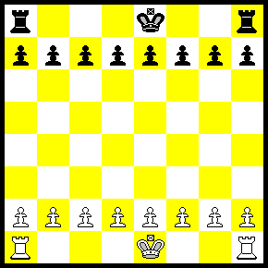

You have learned how to use the Rook and the King.

You can now play variations of the game where each player has:
A) 1 Rook
B) 2 Rooks
C) Kings or No Kings

1) Play without the Kings and try to get a Pawn across the board.
or
2) Play with the Kings on the board and try to checkmate.

Remember, even though you start the game with all of your pieces, most of them are often captured during the game.

Finally at the end you will have a few pieces left that are used to get the checkmate. Learn to use the pieces you have!

Learn to trust in Jesus, He is all you’ll need.
a) White wins in 1 move b) White wins in 2 moves
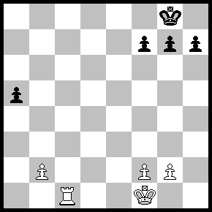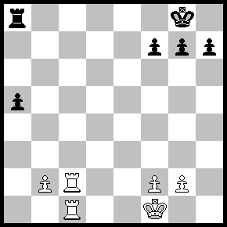

c) Black wins in 1 move d) White wins in two moves
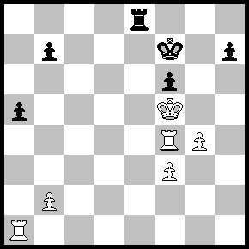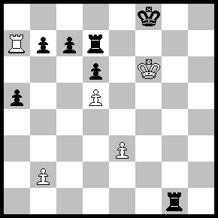

e) Black’s turn but no good moves! f) White wins in two moves.
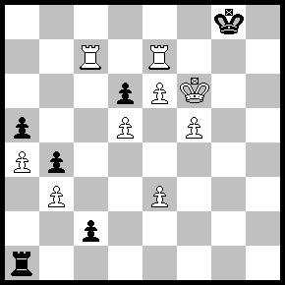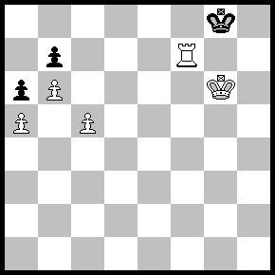

Answers:
a) Rook to c8 Mate (R-c8++)
b) Rook to c8 Check (R-c8+) Rook takes Rook (RxR), Rook takes Rook Mate (RxR++)
c) Rook to e5 Mate (R-e5 ++)
d) Rook to a8 Check (R-a8+), Rook to c8 (R-c8), Rook takes Rook Mate (RxR ++)
e) No matter what Black does, White has a Mate in one move!
(If King to f8: Rook - c8 Mate.... If Pawn - c8=Q, then Rook to e8 Mate)
f) White mates Black in two moves with... Rook to f6. The King must move to h8, then Rook to f8 Mate.
Three Moves: P-c6, PxP, P-b7,P-c5, P-b8-Q

Any time a Pawn crosses the board and reaches the 8th rank, it can be exchanged for any piece except a King
(It cannot remain a Pawn). Therefore, it is possible to have 9 Queens or 10 Rooks) More about this later.

