Is there such a thing as a Universal Language?
Some people think art, music or math might be a universal language.

Is there anything common among the nations of the world that is universal?
Are there any beliefs that would apply in all societies?
Are there some things that all societies might consider Taboo or “wrong”?

One thought is that “love” is universal language.
There is a great song called “Love in any Language” by Sandi Patty

Je t'aime
Te amo
Aishiteru
Ani ohevet othka
I love you

The sounds are all as different
As the lands from which they came
And though the words are all unique
Our hearts are still the same.

Love in any language
Straight from the heart
Pulls us all together
Never apart
And once we learn to speak it
All the world will hear
Love in any language
Fluently spoken here

We teach the young our differences
Yet look how we're the same
We love to laugh, to dream our dreams
We know the sting of pain

From Leningrad to Lexington
The farmer loves his land
And daddies all get misty-eyed
To give their daughter's hand

Oh maybe when we realize
How much there is to share
We'll find too much in common
To pretend it isn't there

Love in any language
Straight from the heart
Pulls us all together
Never apart
And once we learn to speak it
All the world will hear
Love in any language
Fluently spoken here

The rhetoric of government
May keep us worlds apart
There's no misinterpreting
The language of the heart

Love in any language
Straight from the heart
Pulls us all together
Never apart
And once we learn to speak it
All the world will hear
Love in any language
Fluently spoken here.

Another song that talks of a universal love is “It’s a Small World”

It's a world of laughter, a world or tears
It’s a world of hopes, it’s a world of fear
There’s so much that we share
That it’s time we're aware
It’s a small world after all
CHORUS:
It’s a small world after all
It’s a small world after all
It’s a small world after all
Its a small, small world
There is just one moon
and one golden sun
And a smile means
Friendship to everyone.
Though the mountains divide
And the oceans are wide
It's a small small world
There is laughter, joy, and hope. A smile can speak to any heart!

The Bible tells us:
Now the whole world had one language and a common speech. As men moved eastward, they found a plain in Shinar and settled there. Then they said, "Come, let us build ourselves a city, with a tower that reaches to the heavens, so that we may make a name for ourselves and not be scattered over the face of the whole earth. But the LORD came down to see the city and the tower that the men were building. The LORD said, "If as one people speaking the same language they have begun to do this, then nothing they plan to do will be impossible for them. Come, let us go down and confuse their language so they will not understand each other. So the LORD scattered them from there over all the earth, and they stopped building the city. That is why it was called Babel - because there the LORD confused the language of the whole world. From there the LORD scattered them over the face of the whole earth.
(Genesis 11:1-8)

It seems you can go just about anywhere in the world and set up a chess board.
Like iron to a magnet people will be drawn to you.
Chess crosses cultural and language barriers.
Chess is Universal
In 1997, I wrote the first draft of this manual. Since that time, I have been to China many times.
I have learned they have their own version of “chess” called Xiang Xi. It is very similar to “International Chess” but it does have some unique differences. The biggest difference is that “International Chess” is based primarily on a control of force, Xiang Xi uses much more indirect and strategy.
You have already started to learn some of the 'Language of Chess'. In order to be able to learn and study chess, it is important to learn the language of chess. If you learn the vocabulary you will be able to read and write about games so you can communicate with others or replay your own games. Many players used to play chess by mail and now computers and the internet make it easier to play a game with almost anyone anywhere in the world.

Notation:
There are two types of common chess notation. DESCRIPTIVE and ALGEBRAIC. The new standard (post 1980) is Algebraic Notation. However, there are many older books on chess that were written in Descriptive Notation If you want to read and study from the older reference books, you need to know the language. (It is a little like the Bible; most people use translations so they can more easily read and understand the meaning of the text.

The original language of the Bible was Hebrew, Greek, and Aramaic. To fully understand the Bible, some scholars say you need to read it in its original form since the sentence structure, language and grammar add more meaning than just “words”.
If you have a Bible, you should not be afraid to write in it or take notes.
The Bible (BOOK) is not a holy object but “the Word of God” is!

With the increase in computers, word processors and graphic generators, some newer texts are using a notation that uses the SYMBOL of the piece rather than the Letter for the name of the piece.

There is also another form of “Computer Notation” that is even shorter than Algebraic notation and it simply uses the FROM/TO squares. While this does work to describe the activity, it is not as intuitive to read and follow.

An example of a full game in Algebraic and Descriptive notation is at the end of this lesson.
The Rule of Recording
IF YOU ARE PLAYING IN A TOURNAMENT,
YOU MUST RECORD YOUR MOVES IN A FORMAT THAT IS UNDERSTANDABLE AND PLAYABLE.
FAILURE TO RECORD YOUR MOVES
CAN CAUSE YOU TO FORFEIT THE GAME.

Algebraic Notation
The numbering is done from WHITE'S side of the board.
The board is set up with 'a1' in the left hand corner for White.
Remember that a 'light' color square is on White's right
('h1' will be a light square for White).

This is the format that has been used so far in this book.

The Columns (Files) are labeled a, b, c, d, e, f, g, and h.

The Rows (Ranks) are numbered 1, 2, 3, 4, 5, 6, 7, and 8.
Black
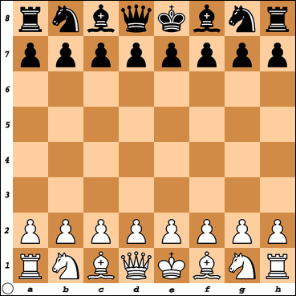
White

The terms Rank and File are old military terms for soldiers.
A standard convention is WHITE moves UP ↑ and Black moves DOWN ↓
Descriptive Notation
Because many good (old) books have been written about chess over the years, it is important to be able to read and understand the older form of chess notation called Descriptive Notation.

The description of the Files is the name of the piece that was originally there.

Finally, there needs to be a reference to the KING SIDE or QUEEN SIDE since there are two Bishops, Knights, and Rooks.
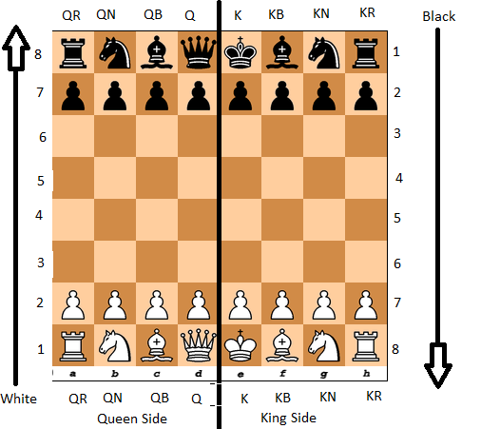

According to Wikipedia, This is an example of how chess notation evolved over a period of time. http://en.wikipedia.org/wiki/Chess_notation#Notation_for_telegraph_and_radio
1614: The white king commands his owne knight into the third house before his owne bishop.
1750: K. knight to His Bishop's 3d.
1837: K.Kt. to B.third sq.
1848: K.Kt. to B's 3rd.
1859: K. Kt. to B. 3d.
1874: K Kt to B3
1889: KKt -B3
1904: Kt-KB3
1946: N-KB3
Modern: Nf3
g1-f3
Algebraic Notation removes some of the confusion with naming the squares but the Descriptive Notation paints a verbal picture rather than an abstract code.

When there is no other piece that can be moved to a square, it is usually an implied pawn move.

The notation to describe the pawn in moving in front of the King might be written as:
White Black
PK4 PK4
Pe4 Pe5
e4 e5
e2-e4 e7-e5
e4 e5

Moving
'-' means MOVE (sometimes the '-' is left out in Algebraic Notation).
The common format for notation is to give the name of the piece and the square where it 'landed'.
P-e4 or Pe4 would be to move the Pawn two squares.
Some players leave out the piece name in algebraic notation for Pawns and would just write e4. Other players like to give the name of the square where the piece came from and where it went. Pe2-e4 (Pe2e4)
And in the shortest form, it could be written e2e4 or simply e4.

If two pieces could get to the same square it is important to identify the FROM square or the name of the piece.
If the two pieces are the same, than the FROM square definitely is required.
Good practice is to use:
the Piece name,
the 'From' square,
and the 'To' square.
It might be longer to write,
but there can never be any doubt as to what piece was moved.
Capturing:
'x' means CAPTURE.
Some players might just write the names of the pieces like: R x B
Others might just write the names of the squares: a5 x c5
Some might use a combination of piece and squares: Ra5 x Bc5.

Other:
+ Check # Checkmate (or ++)
! Good move !! Great move
? Bad move ?? Very bad
!? Interesting move
There are other special moves to be taught later:
0-0 King side Castle (Castle Short)
0-0-0 Queen side Castle (Castle Long)
ep En Passant
= Promotion
 |  | P | Pawn
 |  | R | Rook
 |  | N | Knight
 |  | B | Bishop
 |  | Q | Queen
 |  | K | King

The following game was from the 1995 World Open Round 4 Under 1400 section.
I was Black and did not do very well in this game. The final position was:
Tomboulian
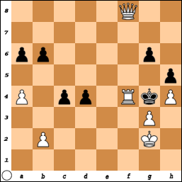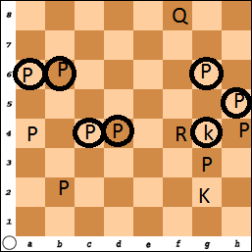
White
My (old) chess computer program created the following Algebraic Notation for this Game: (Notice it used all Capital letters). Newer programs, tools or websites may generate different notation.

1: PD2-D4 NG8-F6 2: PC2-C4 PE7-E6 3: PG2-G3 PC7-C5
4: PD4-D5 PE6xD5 5: PC4xD5 PC5-C4 6: BF1-G2 QD8-A5+
7: NB1-C3 PB7-B6 8: PE2-E4 PD7-D6 9: BC1-D2 BC8-B7
10: NG1-E2 BF8-E7 11: PA2-A4 QA5-C5 12: O-O O-O
13: QD1-C2 RF8-E8 14: BD2-E3 QC5-C8 15: PF2-F4 BE7-F8
16: NE2-D4 NF6xD5 17: PE4xD5 RE8xE3 18: BG2-E4 PG7-G6
19: QC2-D2 RE3xE4 20: NC3xE4 BB7xD5 21: NE4-F6+ KG8-H8
22: NF6xD5 QC8-C5 23: ND5-E3 BF8-G7 24: RA1-D1 PD6-D5
25: RF1-E1 NB8-D7 26: NE3-G4 RA8-C8 27: KG1-G2 PH7-H5
28: NG4-E5 ND7xE5 29: PF4xE5 PA7-A6 30: PE5-E6 RC8-E8
31: PE6xF7 RE8xE1 32: RD1xE1 KH8-H7 33: ND4-E6 QC5-D6
34: NE6xG7 KH7xG7 35: RE1-F1 QD6-F8 36: QD2-D4+ KG7-H6
37: QD4-E5 PD5-D4 38: QE5-E8 QF8-B4 39: PF7-F8=Q+ QB4xF8
40: QE8xF8+ KH6-G5 41: PH2-H4+ KG5-G4 42: RF1-F4 #

The same game in Descriptive Notation is:
1: P-Q4 N-KB3 2: P-QB4 P-K3 3: P-KN3 P-QB4
4: P-Q5 PxP 5: PxP P-QB5 6: B-KN2 Q-QR4+
7: N-QB3 P-QN3 8: P-K4 P-Q3 9: B-Q2 B-QN2
10: N-K2 B-K2 11: P-QR4 Q-QB4 12: O-O O-O
13: Q-QB2 R-K1 14: B-K3 Q-QB1 15: P-KB4 B-KB1
16: N-Q4 NxP 17: PxN RxB 18: B-K4 P- KN3
19: Q-Q2 RxB 20: NxR BxP 21: N-KB6+ K-KR1
22: NxB Q-QB4 23: N-K3 B-KN2 24: R-Q1 P-Q4
25: R-K1 N-Q2 26: N-KN4 R-QB1 27: K-KN2 P-KR4
28: N-K5 NxN 29: PxN P-QR3 30: P-K6 R-K1
31: PxP RxR 32: RxR K-KR2 33: N-K6 Q-Q3
34: NxB KxN 35: R-KB1 Q-KB1 36: Q-Q4+ K-KR3
37: Q-K5 P-Q5 38: Q-K8 Q-QN5 39: P-KB8=Q+ QxQ
40: QxQ+ K-KN4 41: P-KR4+ K-KN5 42: R-KB4++
Here is the start of four chess games. Can you play these moves?
Check the positions on the next page.

This Notation is the LONG WAY (Piece from – to) or (Piece On x Piece On)
 | Game1 |  | Game2 |  | Game3 |  | Game4
Move | White | Black | White | Black | White | Black | White | Black
1 | Pe2-e4 | Pd7-d5 | Pe2-e4 | Pe7-e5 | Pe2-e4 | Pg7-g6 | Pe2-e4 | Pe7-e5
2 | Pe4-e5 | Nb8-c6 | Ng1-f3 | Nb8-c6 | Pd2-d4 | Bf8-g7 | Ng1-f3 | Nb8-c6
3 | Pd2-d4 | Pe7-e6 | Nb1-c3 | Bf8-c5 | Ng1-f3 | Pd7-d6 | Nb1-c3 | Ng8-f6
4 | Bf1-b5 | Bf8-b4+ | Nf3xe5 | Nc6xe5 | Bf1-c4 | Nb8-d7 | Bf1-b5 | Bf8-b4
5 | Bc1-d2 | Bb4xd2+ | Pd2-d4 | Bc5-d6 | Bc4xf7+ | Ke8xf7 | O-O | O-O
6 | Qd1xd2 |  | Pd4xe5 | Bd6xe5 | Nf3-g5+ | Kf7-e8 | Bb5xc6 | Pd7xc6
7 |  |  | Bf1-c4 | Pc7-c6 | Ng5-e6 |  | Pd2-d3 | Bb4-d6
8 |  |  | Qd1-h5 | Pg7-g6 |  |  | Bc1-g5
9 |  |  | Qh5xe5+ | Qd8-e7
10 |  |  | Qe5xh8

Can you write the above games in SIMPLIFIED Notation?
 | Game1 |  | Game2 |  | Game3 |  | Game4
Move | White | Black | White | Black | White | Black | White | Black
1
2
3
4
5
6
7
8
9
10

Game #1  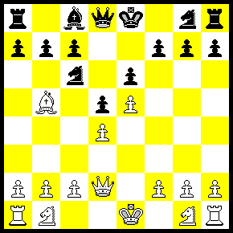 | Game #2  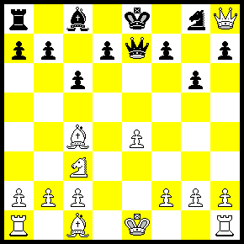
Game #3  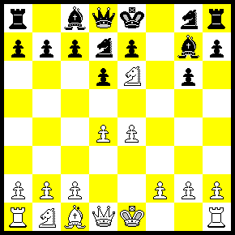 | Game #4  