The QUEEN may be the most powerful piece on the chess board (but that doesn't mean she is the most important). According to chess history, the Queen wasn't always as powerful as she is today. This change was thought to evolve around 1470-1480 with the rule of Queen Isabella. Until this change, the Queen was one of the weakest pieces on the board and could only move one square in any direction. Now, the Queen is allowed to move as far as she wants.

However, just because you have power, you need to use it wisely.
To quote Spiderman, “With great power comes great responsibility!”

At the start of the game the Queen is near the King. When the game gets to the end, as powerful as she is, she (alone) cannot force checkmate on the other King; she needs the help of other pieces. In fact, one common position for checkmate is to have the King and Queen together again.
In life, we often think we can do it all ourselves, but we all need help.

Because the Queen is so powerful, it makes sense your opponent will try to attack her. One common mistake many players make is to bring the Queen out too early. Since the Queen cannot do it all by herself, don't bring her out too early. She will be subject to attack and she can do very little by herself. If your opponent wastes time chasing your Queen around with annoying but meaningless threats, that too is wasteful. (But, when playing against a weaker opponent, there are some traps that can be set up with an early attack).

A Queen must be used with other pieces. A Queen should be wise and control her movement. Even though she is allowed to move all around, she doesn't have too. Now a Queen has a lot of power and can do a lot of things, but she starts the game next to the King and she usually needs to be near the King at the end of the game (if at the end of the game that is all there is left). This is especially true when a Pawn is promoted and exchanged for a Queen.

In the world today there is much talk round equal rights for women and fairness but there is also a Biblical reference for the Queen to be submissive to her husband. It all started in Genesis Chapter 3 where Adam and Eve ate from the Tree of Good and Evil. Because Eve had the ability to choose, she had to take responsibility for her actions.

To the woman he said, "I will greatly increase your pains in childbearing; with pain you will give birth to children.
Your desire will be for your husband, and he will rule over you.”
(Genesis 3:16)
There are some other verses some people may object with today:
Wives, submit to your husbands as to the Lord. For the husband is the head of the wife as Christ is the head of the church, his body, of which he is the Savior. Now as the church submits to Christ, so also wives should submit to their husbands in everything. (Ephesians 5:22-24)

Now this does not mean a husband can abuse his wife, in fact, the next verse is very important to understanding the passage:
Husbands, love your wives, just as Christ loved the church and gave himself up for her to make her holy, cleansing her by the washing with water through the word. (Ephesians 5:25-26)

Wives and husbands, and mothers and fathers, leaders and rulers cannot abuse their power or authority.
Wives, submit to your husbands, as is fitting in the Lord. Husbands, love your wives and do not be harsh with them. Children, obey your parents in everything, for this pleases the Lord. Fathers, do not embitter your children, or they will become discouraged. (Colossians 3:18-21)

Therefore, it is necessary to submit to the authorities, not only because of possible punishment but also because of conscience. This is also why you pay taxes, for the authorities are God's servants, who give their full time to governing. Give everyone what you owe him: If you owe taxes, pay taxes; if revenue, then revenue; if respect, then respect; if honor, then honor. Let no debt remain outstanding, except the continuing debt to love one another, for he who loves his fellowman has fulfilled the law
. (Romans 13:5-8)

Submit yourselves for the Lord's sake to every authority instituted among men: whether to the king, as the supreme authority, or to governors, who are sent by him to punish those who do wrong and to commend those who do right. For it is God's will that by doing good you should silence the ignorant talk of foolish men. Live as free men, but do not use your freedom as a cover-up for evil; live as servants of God. Show proper respect to everyone: Love the brotherhood of believers, fear God, honor the king. (1 Peter 2:13-17)
The following diagram shows when a Queen placed along any edge can cover 21 squares.

You should move the Queen to other squares around the edge:
Files (a and h) or Ranks (1 and 8) and verify the Queen always covers 21 squares when she is on an edge.

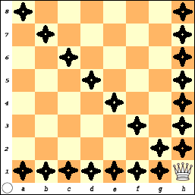
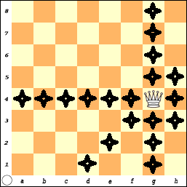
When the Queen is moved one square in from the edge she now covers 23 squares.
Four (4) Squares were missed?
What are they?
f5, e6, d7, & c8
Can you verify this?

How many does she cover when she is two squares in from an edge?
Place on Queen on File: ‘c’ or ‘f’ or Rank: 3 or 6. Did you count 25 squares?
(Can you mark the Squares?)
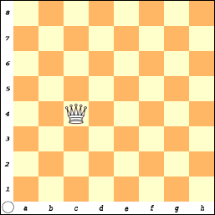
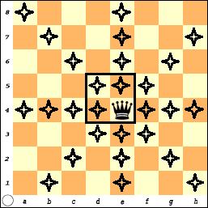
The Queen covers the most squares (27) when she is on one of the ‘center’ squares:
d5 | e5
d4 | e4

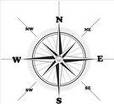
A student once said she remembers how the Queen moves because if you look at the top of her crown, it looks like a compass with little marks pointing in 8 directions.

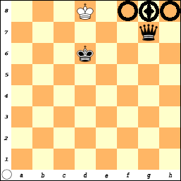
There is a basic pattern for winning with a King and a Queen.

The Queen needs the help of the King.

The “plan” is to get the King an edge and have the two Kings face each other.

The Queen is used to “make box” or “Fence” to limit the King.

Your opponent's King cannot approach the Queen since the Queen can move in any direction. Thus, if the king gets beside the Queen, he is placing himself in Check, which is illegal.
However, you must not get careless and place your Queen next to the opposing King.

While the King cannot place himself in danger, if he is under attack, he is allowed to capture the attacking piece and save himself.

To win the simplified game of a King vs. a King and Queen:
- The King must be against an edge.
- Your King must be in front of the King (1 square away).
- The final move places the Queen in the same rank or file as the King.

There is another square where the Queen can also move to checkmate White? Remember, in order to have checkmate, the King must be in Check.

Try it before turning the page to see the solution.
SOLUTION: Queen - D7 is checkmate #

Practice putting the Black King and the White King and Queen at various places on the board and work on this exercise until you can do it.
Practice... Practice.... Practice....

Once your game gets to this stage,
it should never take any more than 10 moves to finish the game!

Many new players hate this exercise. What I have often heard is "Why should I practice this? My games never get this far - I always get checkmated early."
Forcing checkmate means you have the ability to use your pieces together.
The whole purpose of chess is to checkmate your opponent.
All the moves at the beginning are just to get to the end. The principle and this exercise is important because it will help you learn how to use just two pieces as a team without being distracted by all the other pieces on the board.
If you can solve the easy problems then just maybe you'll be able to solve the problems when other pieces are in the way.

Do not get careless. Even though the Queen is very powerful piece, she may be captured if she makes a wrong move.
Black thought the game was over here.

The Checkmate that wasn't!
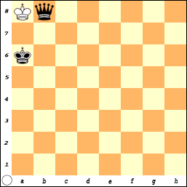
Black just played his Queen to b8 and announced “Checkmate”.
(It is Check, but is it over?)

White knew she could not block or move her King but then she remembered –B.M.o.C.
Block, Move, or CAPTURE!

There is nothing to prevent White from capturing the Black Queen.
Kings are allowed to capture pieces.
(K x Q)
Since two Kings can never be beside each other, this game is a Draw or tie.
Stalemate, the win that got away!
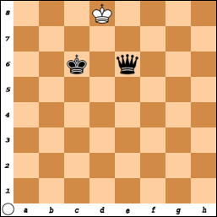
It is easy to get a stalemate position with the Queen.

Practice setting up positions that are a stalemate.

Always make sure if the King is not in check, he has at least one square to move to.

If it is White to move, this would be a stalemate.

The Stalemate that wasn't!
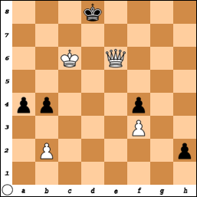
In this example, Black became very happy.
He knew he really should not win this game.
White had just moved her Queen to e6.

Black looked over the board and realized there was no legal move for his King and announced to his opponent the game was a stalemate and draw.

The Black King is NOT in Check and there is no legal move the KING can make.

Just as they were about to shake hands,
White remembered while there were no legal moves for the KING,
Black still had three possible other moves that could be made.
Pawn-a3, Pawn-b3, or Pawn-h1 = something (promote).

Sometimes when you are playing and there does not seem to be any way to win, you move and give up pieces with the hope you are in a position to claim a stalemate. Some players when faced with defeat “resign” and give in. When you resign, you are admitting defeat and are giving your opponent a victory. In every game, there is always a chance for a mistake to be made so make your opponent earn the victory.
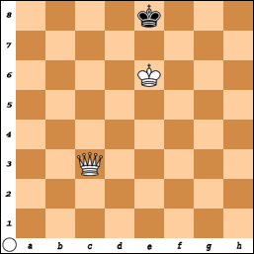  #1) White moves and wins with 1 move!  (and it can be done 2 ways) | 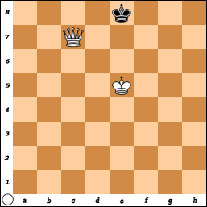  #2) White moves and wins in 2 moves.
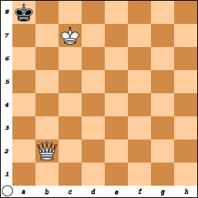  #3) White moves and wins in 1 move.  (There are 5 ways to do it!) | 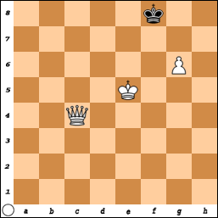  #4) White wins and can do it with 1 move!
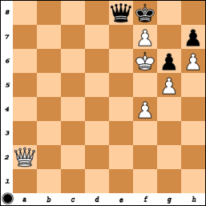  #5) Black has a real problem  but there is a saving move. | 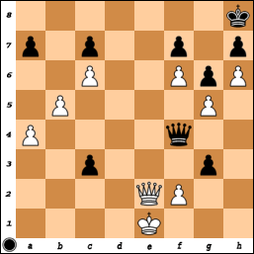  #6) White would win with Queen-d8, but it is Blacks move! What is a good move?
Answers to Queen Puzzles

#1 Since the King is along an edge and the Kings are facing each other, Queen to c8 is checkmate. (Q-h8 is also a checkmate).

#2 The Black King is ‘fenced in’ along the back row and can only move to f8. So, White can either move King to e6 or f6.
Black must move to f8 and then White moves Queen to e7 Mate.
(If white plays King-e6, King-f8, Queen-c8 is also checkmate)

#3 There are five ways that White can win.
Queen moves to: b7, b8, a1, a2, a3.

#4 White could work on making the ‘fence’ with Queen-c7 and then moving the King around and getting checkmate.
But, Queen to f7 is checkmate since the Pawn protects the Queen.

#5 Black is in a lot of trouble here but she does have a clever move!
Queen- e6 Check.
If either the King or the Queen captures the Queen, the game is a stalemate. (but, White must get out of check).
A really clever move is Q-e7 Mate.

#6 White can win the game with Queen to e8 checkmate, but it is Black’s turn.

Two possible options are: Queen - d2 Check or Queen x P-f2 Check. After the exchange of the Queens, Black has 2 pawns and the White King is too far away to stop both of them from advancing.
Q-C1 + is also possible: … Q-D1 QxQ+ KxQ
The Game-Of-Pawns
and Queens
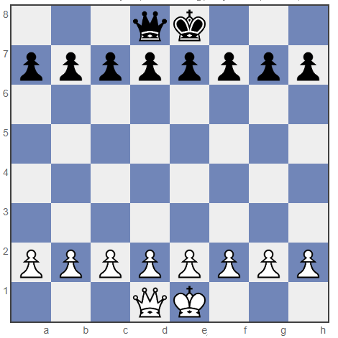

Queen and the King

You could play the game with or without the Kings.
- Play without the Kings and try to get a Pawn across the board.
or
2) Play with the Kings on the board and try to checkmate.

Remember, even though you start the game with all of your pieces, most of these are often captured during the game. Finally, at the end, you will have a few pieces left that are used to get the checkmate.

YOU PLAY THE ENTIRE GAME TO GET TO THE END!

Learn to use the pieces you have.
It is not really important to think what you have lost
and what you have left,
but how wisely do you use what you have been given.
This Page Left Blank

