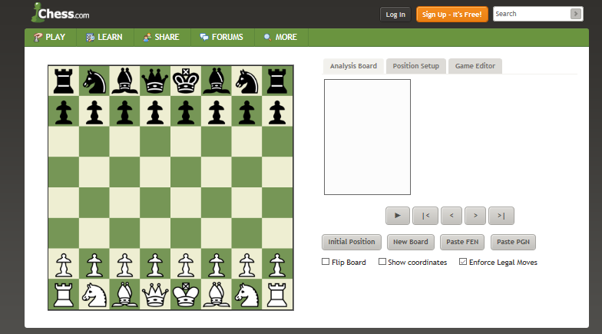
https://www.chess.com/analysis-board-editor

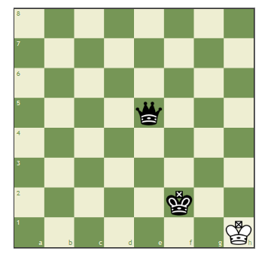  1) | 2)  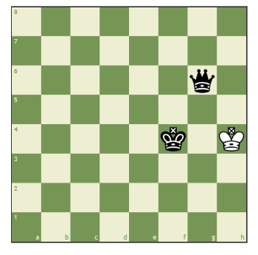 | 3)  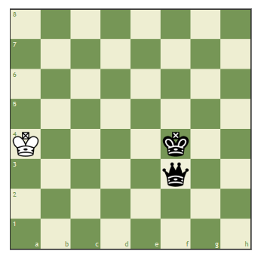
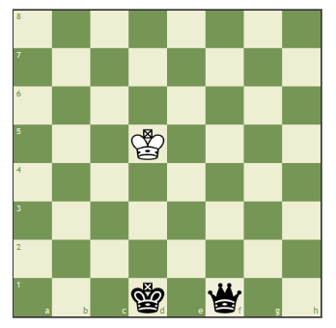 | In order to win with a Queen and King vs a King:  - A) The King must be against a wall (edge).  - B) The other King must be in front of it (or one square to the left or right).  - C) Sandwich the King. K-Q-K  - D) Or be In front of the King and move the Queen to the same column or row as the King. | Puzzles  http://www.chesspuzzles.com/  REMEMBER:  There cannot be CHECKMATE  IF THE KING  IS NOT IN CHECK!

