The game of chess is WON with Checkmate. This is where the King in under attack and could be captured on the next move. However, the Kings are never removed from the chessboard.
In order to have Checkmate, The king must be in Check. If while in Check, and the player fails to make a legal move to get out of check, he is allowed to take bake the move and make another legal move. A player must always get out of check. If there are no legal moves to get out of check, then the game is over with Checkmate.
A player may not skip a turn.
Kings can never be on adjacent squares. (Next to each other)
If the King is NOT in check, but has no other legal moves to make (you cannot place yourself in danger), then the game is a Stalemate.
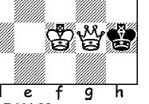
Because the Queen can move in eight different directions, it is very common to get a stalemate with a King and Queen.
In order to win with a King and Queen vs a King, The King must be against an edge (or in the corner). A Classic position is:
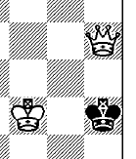
Another final position for checkmate is the Kings face each other and the queen makes a final Check in the same rank or file as the King.
In the next position, the very worst move for White is: K- f2.
This covers the escape square of g3 and the game is a Stalemate.
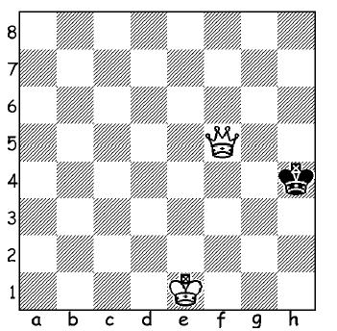
The ‘Correct” move is for White to restrict Black to the h file. Queen – g6.
The Black King must move to h3.
The classic ‘Final’ position for the Kings to be opposite each other White plays: K-f2.
If Black plays K-h2, then Q-g2 Mate #.
If Black moves back to h4, then White plays K-f3.
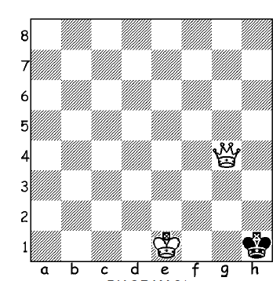
The king is forced to return to h3 and White wins the game with Queen – g3 #

Another way to finish the game is to have the king in the corner. Using the above example, after White plays Q-g6, Black must play K-h3.
White continues to bully or push the king to the corner: Q-g5.
The King must continue to retreat with K-h2 and White responds with Q-g4.
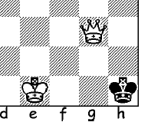
Black only has one move and that is: K-h1.
White MUST NOT PLAY Q-g3 since this would make a stalemate position.
White should now play either K-f1 or K-f2 followed by Q-g2 Mate #

