The KING is the most important piece in the game of chess!

The KING is never removed from the board.
Without a King, there can be no game!

Each side (or player) may have only one King.

Unlike Jesus who is the ultimate King
with the ultimate power,
in the game of chess, the King has very limited power.

Some people have heard God is the ultimate power and since Jesus is the 'Son of God' he may have less power than the Father. This is not true. Jesus is not a son as we think of a human son is to his father. This is the idea behind the Christian Trinity: 3-in-1; God the Father, Jesus the Son, and the Holy Spirit. They are all ‘Co-Equal’.

St. Augustine is given credit for the quote,
"It doesn't make sense and if you try to understand the Trinity, you will lose your mind.
But, if you don't believe it, you will lose your soul."

It is really not hard to explain. God is the “Father” but he made himself in the form of a baby and went through all of the feelings and temptations of a man in the body of a man called Jesus. But, Jesus was not a man - He was sinless and he was God. When he arose from the grave, he said another would come to be with us and that is the Holy Spirit. All three are God, but in different forms.

In the beginning was the Word, and the Word was with God, and the Word was God. He was with God in the beginning. Through Him all things were made; without Him nothing was made that has been made. In Him was life, and that life was the light of men. The light shines in the darkness, but the darkness has not understood it.

..... The Word became flesh and made his dwelling among us. We have seen his glory, the glory of the One and only, who came from the Father, full of grace and truth. (John 1:1-5, 14)
You might want to think of yourself as the King or General on the chess board. Even though you are a very important person, you cannot do anything without all the pieces working together. You have a kingdom and an “army” to protect you, but you also have to go out and attack your opponent.

You must balance your Offence and Defense to be successful.

The King is the tallest piece on the chess board, and he is not ashamed to show his faith with a tall cross on his head. However, just because a person wears a cross, it doesn't mean they are a Christian.
My pastor often remarked something along the lines of:
“The only people who should be allowed to wear T-shirts or symbols with a religious message are those who, when others see them, the message of Jesus is loud and clear.”

In other words, "Actions speak louder than words". What you do is more important than what you say. Are you “Walking the Walk” and “Talking the Talk”?

But along the same lines, just coming to church every Sunday does not make you a Christian any more than going to gas station makes you a car.

A Christian is proud to stand under the cross for the one who was nailed to the cross, died, was buried, and arose from the dead to pay the debt for the sins of all mankind. God had a plan for the world from the very start!
Through temporary suffering, there is ultimate glorification.

Be like a King and stand tall and proud for the:
King of Kings and Lord of Lords. (Revelation 19:16)

You know the message God sent to the people of Israel, telling the good news of peace through Jesus Christ, who is Lord of all.
(Acts 10:36)
In the game of chess:
1) A King is never captured or removed from the board.
2) A King may only move one square at a time on any turn.
3) A King may move in any direction.
4) A King may never put himself in danger and must get out of danger!
5) A King may capture pieces.
6) A King can never be next to (adjacent) another King.
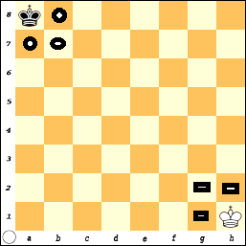
When a KING is in the corner he touches the fewest number of squares: Three.
From a8, the King covers: a7, b7, and b8.

When the King is on h1,
he covers: g1, g2, and h2.

What squares would the black King cover if he was on h8?

What squares would the white King cover if he was on a1?
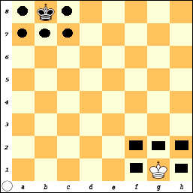
When the KING moves out of the corner to any other square around the edge of the board, he has the ability to reach five squares.

What squares would the king cover if he was on a4?

What about being on h6?

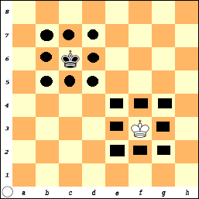
Finally, as the King moves away from the edge and into the center, he has the ability to reach any eight adjacent squares.

A King can be an important piece in the battle, and his ability to be effective (and cover more squares) increases as he moves away from the edge.

This does not mean that the King should always move into the center.

In some cases, it is better to leave the King protected in a corner.

When the King is in the center, he not only has the ability to attack adjacent squares, but he is also open to attack from eight directions.
When you move out into the name of Jesus, you will be attacked for your faith.
“If the world hates you, you know that it hated me before it hated you. If you were of the world, the world would love its own. Yet because you are not of the world, but I chose you out of the world, therefore the world hates you. Remember the word that I said to you... If they persecuted me, they will also persecute you... because they do not know Him who sent Me" (John 15:18-21).

As King, you are not just a passive player in the game.
The King must be an active participant in the game, especially at the end.
The King has the ability to make decisions and get involved.
God wants us to be involved. See where He is at work and join Him.
What have you done for your Savior and Lord lately?
God knows your heart; pray you can know God and be where you are needed.

The Game-Of-Pawns (Add the Kings)

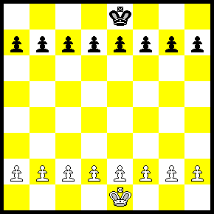

Play the 'Game-of-Pawns' but now the King can be an active player.
The objective is still to get a Pawn across the board.
Remember:
  - A King may only move 1 square in any direction.
  - A King may not place himself in danger of being captured.
  - The King is never removed from the board.
  - Pawns may not move backward.
  - Each Pawn may move 1 or 2 squares the first time it moves.
  - Pawns move forward but capture diagonally.

