Chess is a game of STRATEGY played between two players (opponents, armies or sides) called a White (light) and Black (dark).
Both sides have the same pieces: King, Queen, Rook, Bishop, Knight and Pawn.
Pieces are never “Killed”. They are captured and removed!
You never have to talk or communicate in any way with your opponent during a game. (It is a curtesy).
CHECK is the word used to signify the King is under attack and could be captured on the next turn. (You never take the King)!
CHECKMATE is the word used to signify the King is under attack and has no escape. (Game Over).
A DRAW is a Tie Game. Players can ‘Agree’ to a Draw or an official can call the game based on “No Winning Possibilities”.
A STALEMATE also ends the game. The King is not in Check (thus it is not Checkmate), but there are no legal moves for any piece. If there is any legal move, then it is not a stalemate!
The King is NEVER captured or removed from the board. (Loss with dignity)!

Name | Picture | Symbol | Description | How it Moves
1 King  K | 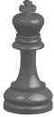 | 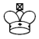 | The King is the most important piece in the “army”.  If he is “captured” with checkmate, the game is over.  The King is never taken off the board! | 1 square in any direction.  Forward  Backward  Left  Right  Diagonally  The King cannot put himself in danger and must get out of check. | 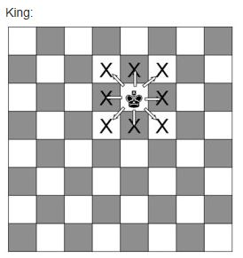
1 Queen  Q | 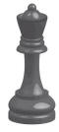 |  | The Queen is the most powerful piece.  9 Points (Major).  Points are only used to evaluate certain trades.  Points have no impact on the outcome of the game. | Any number of squares in any direction.  Only in 1 direction per turn.  The Queen starts on her own Color square.  Black Queen on a Black Square (d8).  White Queen on a White Square (d1). | 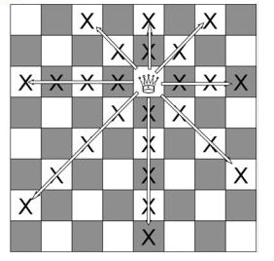
2 Rooks  Or  Castles  R | 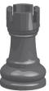 | 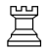 | Rooks are strong pieces (Major) which are good at attacking the enemy and defending your King.  Sometimes the Rook is called a “Castle”.  5 Points (Major).  A Rook can always cover 14 Squares. | Any number of squares Forward, Backward, Left or Right. (Not diagonally).  Horizontally in the Rows  (Ranks: 1 - 8).  Vertically in the Columns  (Files: a - h).  Only in 1 direction per turn. | 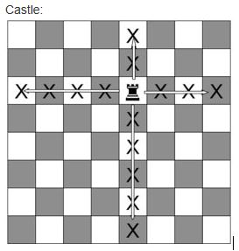
2 Bishops  B | 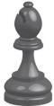 | 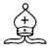 | Bishops are good at attacking late in the game.  Because Bishops move diagonally, they always stay on the same color square they started on.  One Bishop is on the Light square and the other is on the Dark Square.  3 Points (Minor). | Any number of squares diagonally.  Never changes color of the square it started on.  Only moves in 1 direction per turn.  If you ever notice you have two Bishops on the same color square, a mistake was probably made during the game.  (Unless there was a Pawn Promotion.) | 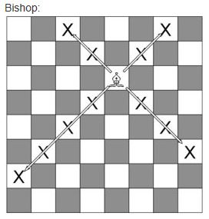
2 Knights  N | 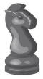 |  | Knights work best when there are lots of pieces on the board, and they can use their ability to jump over other pieces.  3 Points (Minor).  If it starts on a Light,  it ends on a Dark!  It only captures the square it lands on. | “L shaped” move.  Two squares forward (or back) and one square across Or  Two squares across and one square forward (or back)  Or  One square ‘like a Rook’ and one square ‘like a Bishop’.  The Knight can ‘jump over’ other pieces while doing this. | 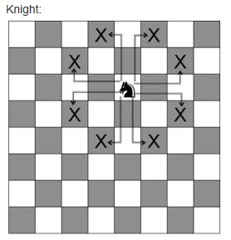
8 Pawns  P | 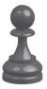 |  | Pawns are the “foot soldiers” in the army.  They gradually advance on the opposing army, but also need to defend the King.  1 Point (not a piece).  Any pawn that advances across the board to the 8th rank can be exchanged (promoted) for any other piece  But not for a 2nd King!  You could have  9 Queens or  10 Rooks, (but this is very unlikely and unnecessary!) | Usually one square forward.  Each pawn may move two squares forward the first time it moves.  If it is capturing an opposing piece, however, it moves one square forward diagonally.  It cannot move forward and capture diagonally on the same move.  Pawns never move backwards.  ‘En passant’ is a special move for the Pawn. | 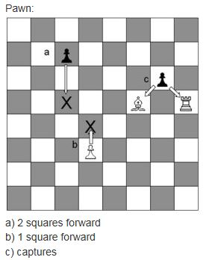

Set up the board with a White (Light) square on the corner of the board by your RIGHT hand.
The (a1) square goes in White’s LEFT Hand Corner.
Then, place the armies (men/pieces) on the board as shown in the picture below.

8 | 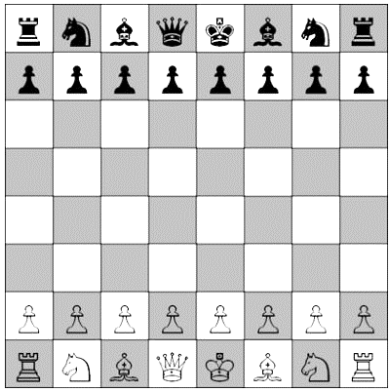
7
6
5
4
3
2
1
 | a | b | c | d | e | f | g | h

The White Queen starts on a White square (d1), and the Black Queen starts on a Black square (d8).

White and Black take turns to move (in chess, White always go first).
Players may choose who plays White.
A piece can capture an opposing piece by landing on the square the piece is on.
A player may not Pass or Skip a turn!
The goal of the game is to “capture” the enemy King. If you move one of your pieces to attack the King and you could capture him on the next move you may say “check”. This means, watch out for your King! (It is an optional warning!) – but, if your opponent does not see the danger and makes another move, you must then notify him and he must have the chance to change his move and get out of Check!
If the King is in check, the King may defend by either:
Blocking the attack with another piece, (usually not good since it sets up a PIN) or
Moving the King out of the way of the attack (watch out for secondary attacks)
Capturing the piece that threatened to capture the King. (The King can capture pieces also)
If your opponent cannot defend the King in any of these ways, you say “checkmate” # (Game Over).
This means “the King is captured”.
Remember that you can never move your King into “check” or make a move that exposes your King to check. (Illegal Move).
Kings are never removed from the board!

