If you are like many new chess players, you want to jump in and start 'playing' a game of chess. The cover of this book has a picture of all the pieces needed to play the game. It is exciting you want to jump in, but you are not ready to handle all of the decisions that need to be made.
There are not many rules in chess but there are some.

Every piece has special abilities and duties to do in the game.
You must learn and master the power of each piece so you can use it appropriately to achieve your goals and objectives. Just as a baby learns to crawl and walk before it can run, you must build up your understanding in order to become a good chess player.

This is just the opposite of becoming a Christian. Many people think they cannot become a Christian until they have learned how to master everything in the Bible and have a complete understanding of GOD and how He works.
We (as finite created beings) can never understand an infinite, eternal creator, God.
However, we can understand what He has done for us through His Son, Jesus Christ. Becoming a Christian is the easiest thing in the world to do.
Living like a Christ is the hardest thing you will ever do!

Moves made without a plan, purpose, or knowledge is wasted effort.
Failing to Plan, is a plan to fail.

This is a little like the story of the airplane captain who came on the speakers to inform the passengers: the weather is great, the engines are allowing them the travel at 500 miles per hour, but they have just lost all the navigation equipment and have no idea where they are going.... but not to worry because they are making great time.

You have to know your purpose, set goals, make a plan, and set a course and direction to reach it. Sometimes you will need to make adjustments and changes to the plan and sometimes you will have to make all new plans.

Some teachers of chess used to say “when it doubt, push a pawn”.
This is some really bad advice. Since Pawns cannot move backward, their position and movement is extremely important. Advancing a pawn without having a plan is contrary to a good strategy. A pawn in the wrong place at the wrong time can actually turn into a weakness and be a hindrance to the development of your other pieces.
Some people think God is playing a game with humanity and we are His Pawns.
Their logic says that since God is in control of everything, including people, there is nothing anyone can do that maters. Everything is up to God and our fate is predetermined. This would be a very sad existence if there was nothing anyone could do to impact or change their life. God is in control and sometimes He allows things to happen and sometimes He causes things to happen. But, God does not want us to be puppets or “toys” in His hands – We are not God’s playthings.

God gave people a free-will and the ability to make choices. God wants us to come to Him and worship Him freely. God will not force you to come to Him, nor will He punish you for not coming to Him. God does not want you to worship Him and respect Him out of fear of pain and punishment.

God made us because he loves us.
The choice to follow Him is only one that you can make.

Another lesson will address the Pawn and some of its special properties in more detail.

A quick game can be created using only the Pawns and a few rules how they move. Students should practice and master this game. I have seen many games where after many hours and moves, the only pieces left are the Pawns.

How does a Pawn move?
1) Pawns only move forward -
He is the only “man” who cannot move backward.

2a) Any Pawn may move 1 or 2 squares the very first time it moves.
b) After a Pawn is moved once, it may only move 1 square at a time.

3) Pawns may not move forward if there is something on the square in front of it.

4) Pawns 'Move' forward but 'Capture' diagonally.

5) There are other special rules for Pawns but you'll have to wait.

To be able to talk about the “Board”, every square has a name that is a Letter and Number.
BLACK is at the Top and moves Down ↓the board. White is at the Bottom and moves Up ↑.

The Choices of the Pawn
The Pawn usually may have four choices to make:
1) Move ahead (1 or 2 squares if it is the 1st time to move)
2) Capture forward right
3) Capture forward left
4) Do not move
5) Special moves that may occur: (En passant and Promotion)
Puzzles with Pawns
Before you play the Game-Of-Pawns, you should practice setting up the positions in the diagrams and answer the questions.
Cover the answers before you try to solve these.
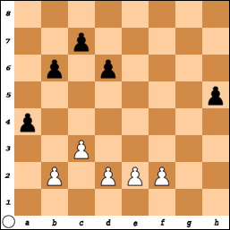 | #1) Black Pawns on:  a4, b6, c7, d6, h5.  White Pawns on:  b2, c3, d2, e2, f2.  White moves first,  but Black is going to win this game!

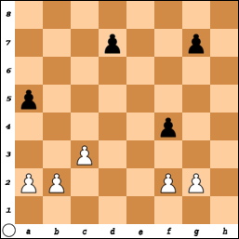 | #2) Black Pawns on:  a4, d7, f4, g7  White Pawns on:  a2, b2, c3, f2, g2  What is the move that WINS for White?

Answers:
#1: All black needs to do is keep moving the ‘h’ Pawn.
White can do nothing to stop the advance and Black “wins” in 4 moves.

#2: Pawn-b4. If the Black Pawn on a5 does not capture it, then White continues to move it down the board. If a5 takes the b4 Pawn, then c3 takes Black back and White still gets across the board first.

The Game-Of-Pawns
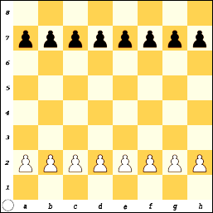
Rules:

The Game-Of-Pawns is an easy way to start you thinking about moves.
It is not a “real” game of chess!

When you play this game, the way you win is to be the first player to get a Pawn to the other side of the board. (Promotion)

If you cannot move, the game is over and the player with the most Pawns is the winner.

If both players have the same number of Pawns, the game is a tie or a DRAW.

Remember, Pawns may move one or two squares on their first move and then only one square at a time after that.

Pawns move forward but capture diagonally.

White moves first and you may not skip or pass a turn.

Play the game many times for practice.

After each game, switch sides and play with the other color.
Practice the 'Game-Of-Pawns'

