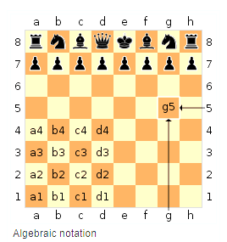
You can play chess without knowing how to read or write chess notation. But, to take your pursuit of understanding and study to a higher level it is important to develop a common language for instruction and dialog.
If you plan to play in competitive tournaments, the use of a Score Sheet and Notation is usually required.
Over time, the “Language” used to describe or notate chess has evolved and changed. There are many classical books written in the older format called Descriptive Notation.
Descriptive Notation is good for people to create a visual or mental image about what is going on but is difficult for computers.
In 1980 the Algebraic Notation became the international standard (F.I.D.E)
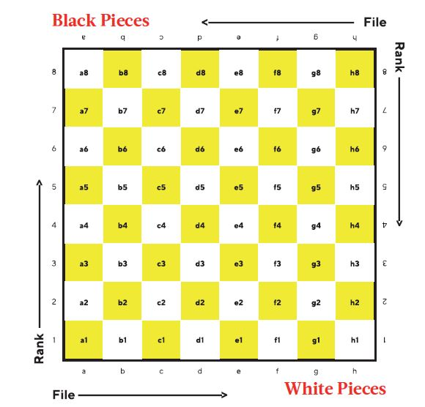
https://en.wikipedia.org/wiki/Algebraic_notation_(chess).
Algebraic Notation uses a Coordinate system of Letters (a-h) for the columns (FILES) and Numbers (1-8) for the Rows or (RANKS).
The board is set up with the LIGHT Square in the Right Corner.
Square (a1) is positioned on WHITE’s Left hand side. White is typically shown on the “Lower” or “Bottom” side and BLACK is at the “Top”.

Recording your moves is done primarily for the purpose of being able to review the game later (ANALYSIS) and to learn from your mistakes or seek to discover something new or better for the next time you play a game.
In the simplest form, you really just have to specify the “FROM” square and the “TO” square. You can add more description to the notation by:
a) Adding the NAME of the Piece
(R = Rook, N = kNight, B = Bishop, Q = Queen, P = Pawn, and K = King)
Some books leave out the ‘P’.
b) You can then also add a notation for: MOVEMENT (-) or CAPTURE (x)
c) The name of the piece being captured.
d) There are special codes for:
Castling (O-O King Side or Short) O-O-O (Queen Side or Long)
En Passant (ep) A very special capture made by a pawn.
Pawn Promotion (=) (Getting the Pawn across the board).
e) Other common symbols are:
+ Check
# Checkmate
? Questionable (Bad) move
?? Very bad move BLUNDER
! Interesting move
!! Excellent move

Some books may also use the symbolic pictures for the pieces.
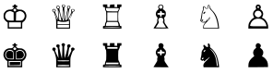 OR 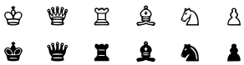
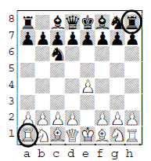 | Moving the Pawn in front of the White King could be:  Pe2-e4  P-e4  Pe4  Some players leave out the piece name in algebraic notation for Pawns and would just write:  e4
If two pieces could get to the same square it is important to identify the FROM square or the name of the piece.
If the two pieces are the same, than the FROM square definitely is required.
If the Knight took the pawn, writing “Nxe6” would not be adequate to indicate which white Knight was used.  How could we tell the difference?  We include the rank  and write: N7xe6  or g7e6 or Ng7xe6  You might also write: N7xP | 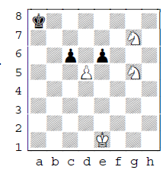 | There is a similar situation with the black pawn taking the white Pawn on d5.  We need to include the file of the attacking pawn and write:  cxd5 or Pc6 x P  or c6d5 or c6 x d5  Pc6 x Pd5
Good practice is to use:
the Piece name
the 'From' square
and the 'To' square
(adding the name of the captured piece adds even more description to the move)
It might be longer to write,
but there can never be any doubt as to what piece was moved.

