IT'S YOUR MOVE

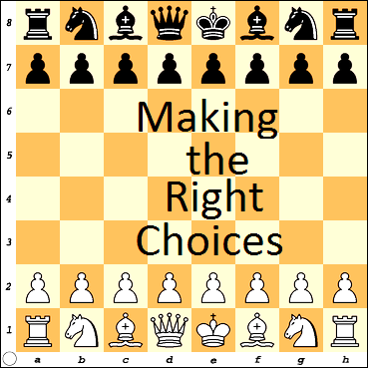
A Basic Instructional Chess Manual
and Christian Devotional Guide

Revised: July 2023, June 2022, June 2015
Original: January 1998

Nolan Tomboulian
1214 N. Pasteur Street
New Bern, NC
U.S.A. 28560
252-675-0176

HTTPS://NewBernChess.Club
ContactNolanT@Gmail.com
This Page Left Blank

